**Queues**

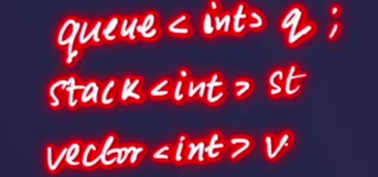

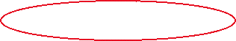

* We can also define queue as we used to define stack and vectors.
* 🡪 queue is also of unlimited size.



* 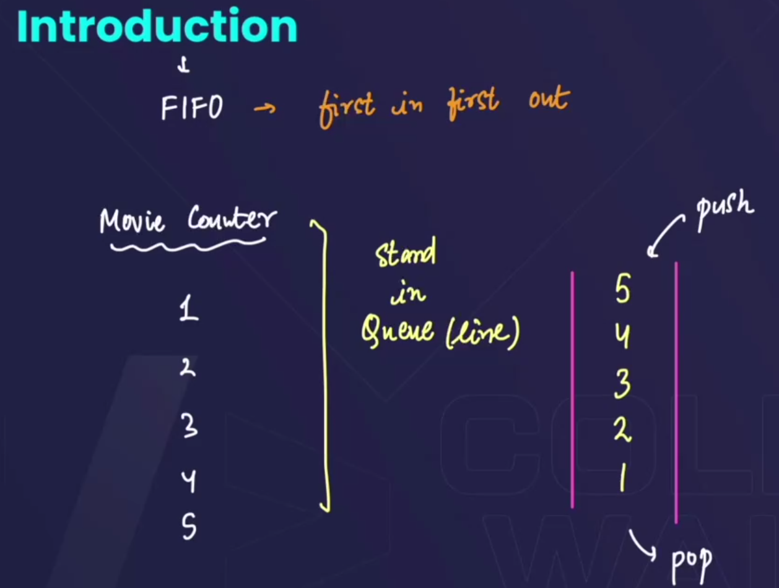🡪stack m hm ek side se hi push krte h, and ussi side se pop bhi krte h, but in queue, hm ek side se push krte h and opposite side se pop krte h .

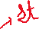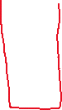

**# We can draw the diagram in different ways:** 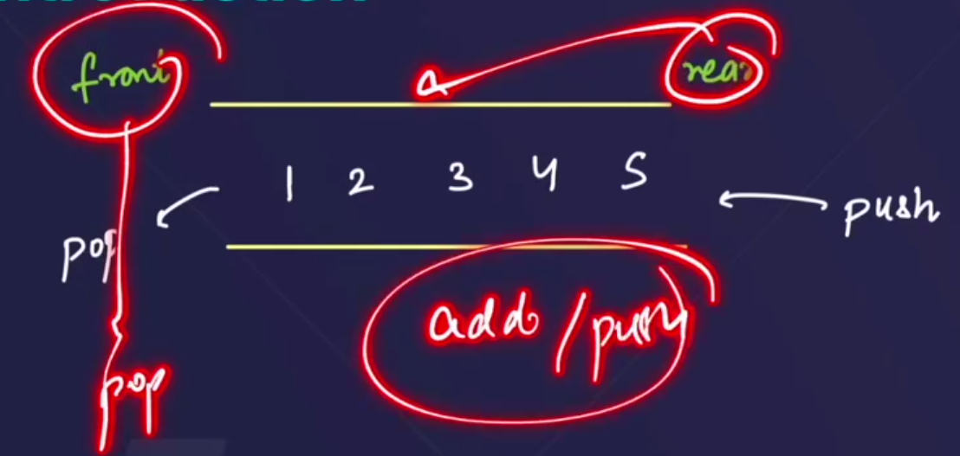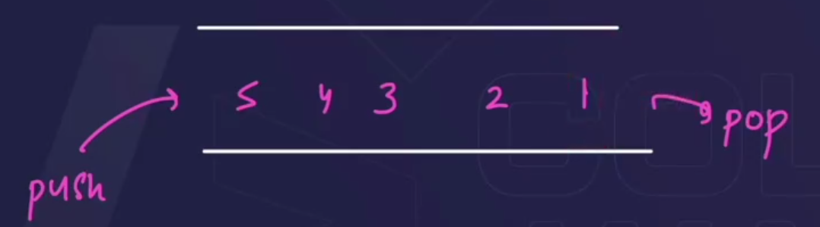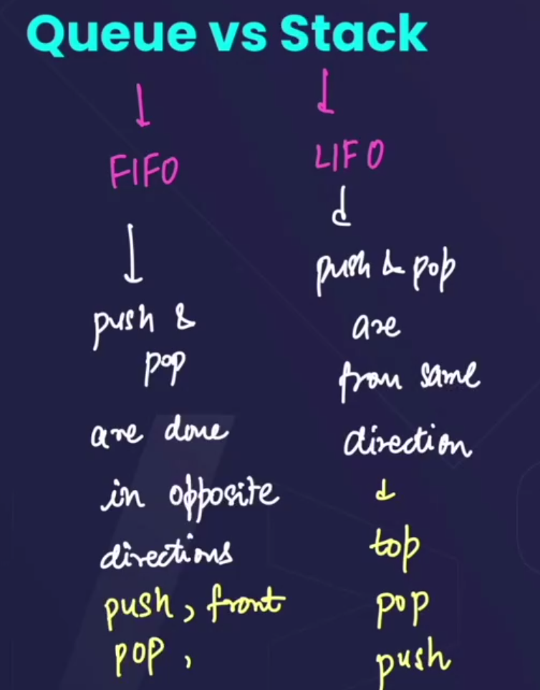🡪 in **stack** the important operations that can be performed are **top, pop, push**, and in **queue** the important operations performed are **push, front**(returns the front element present in the queue) **, pop.**

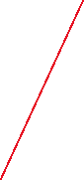

* 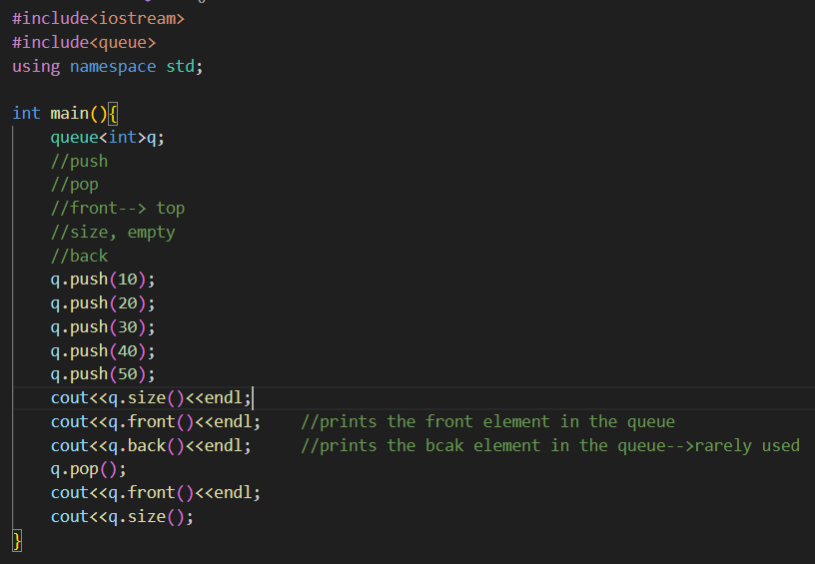 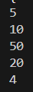

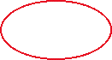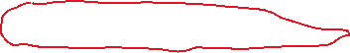

* In queue we can perform these basic operations.
* **Note:** we always push from rear(peeche se), and pop from front.
* **Dry Run of above code:** 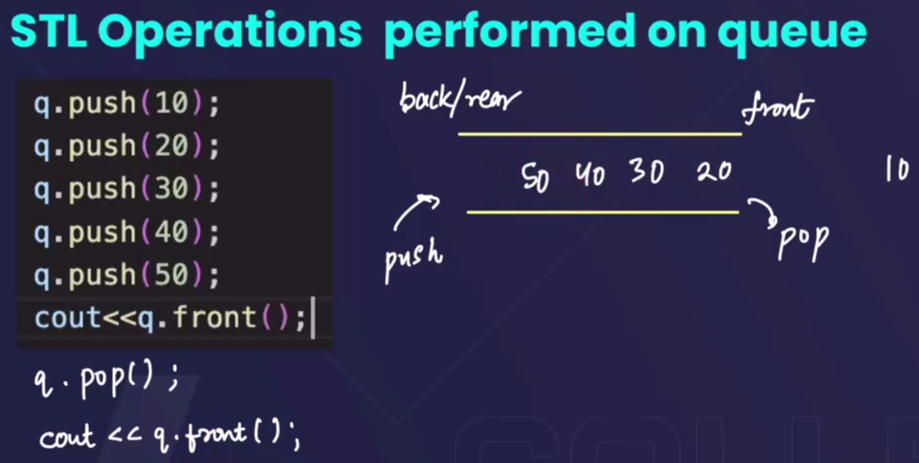
* 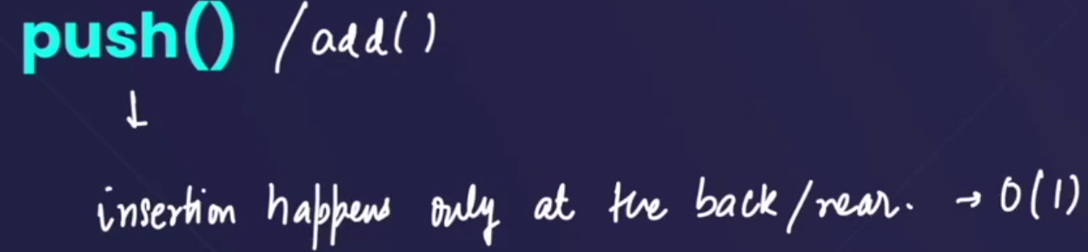🡪 In queue, push operations are only performed from the rear and have time complexity = O(1)
* 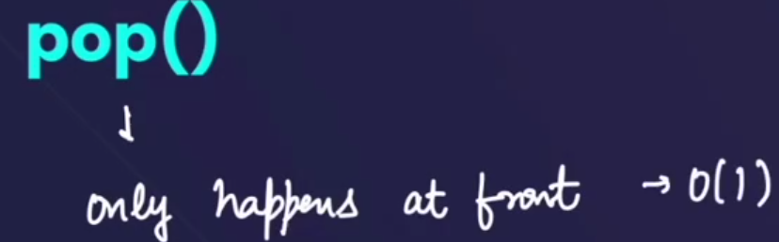
* 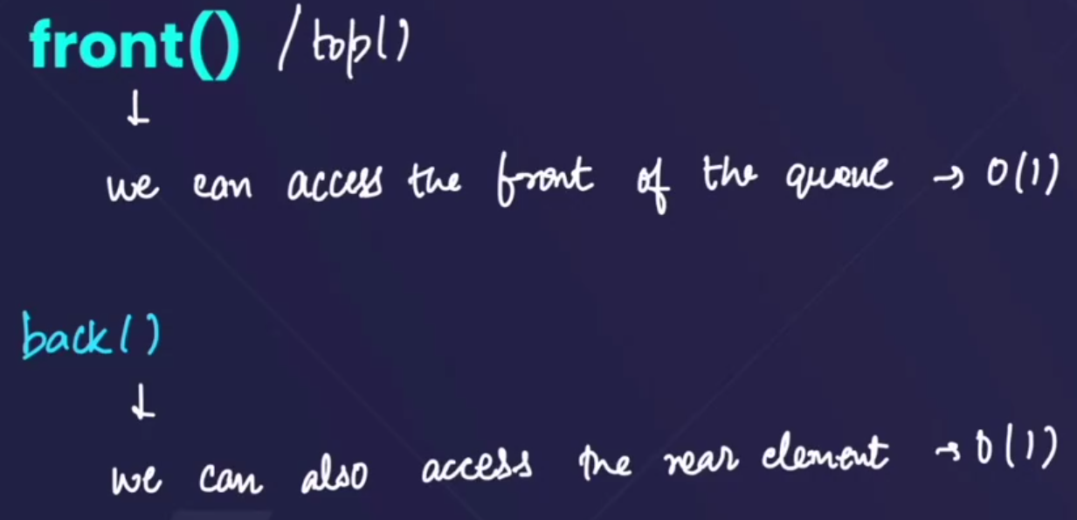
* 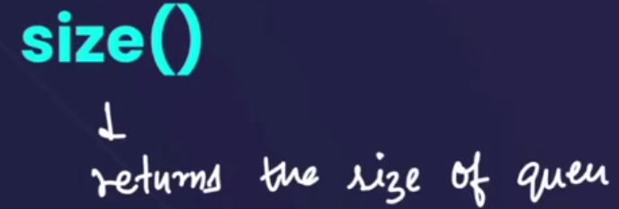
* 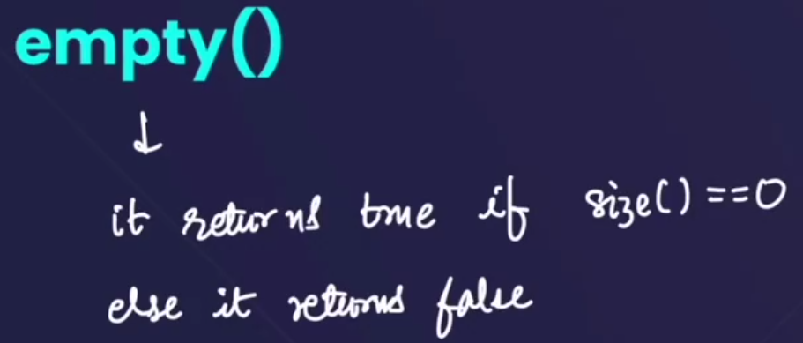

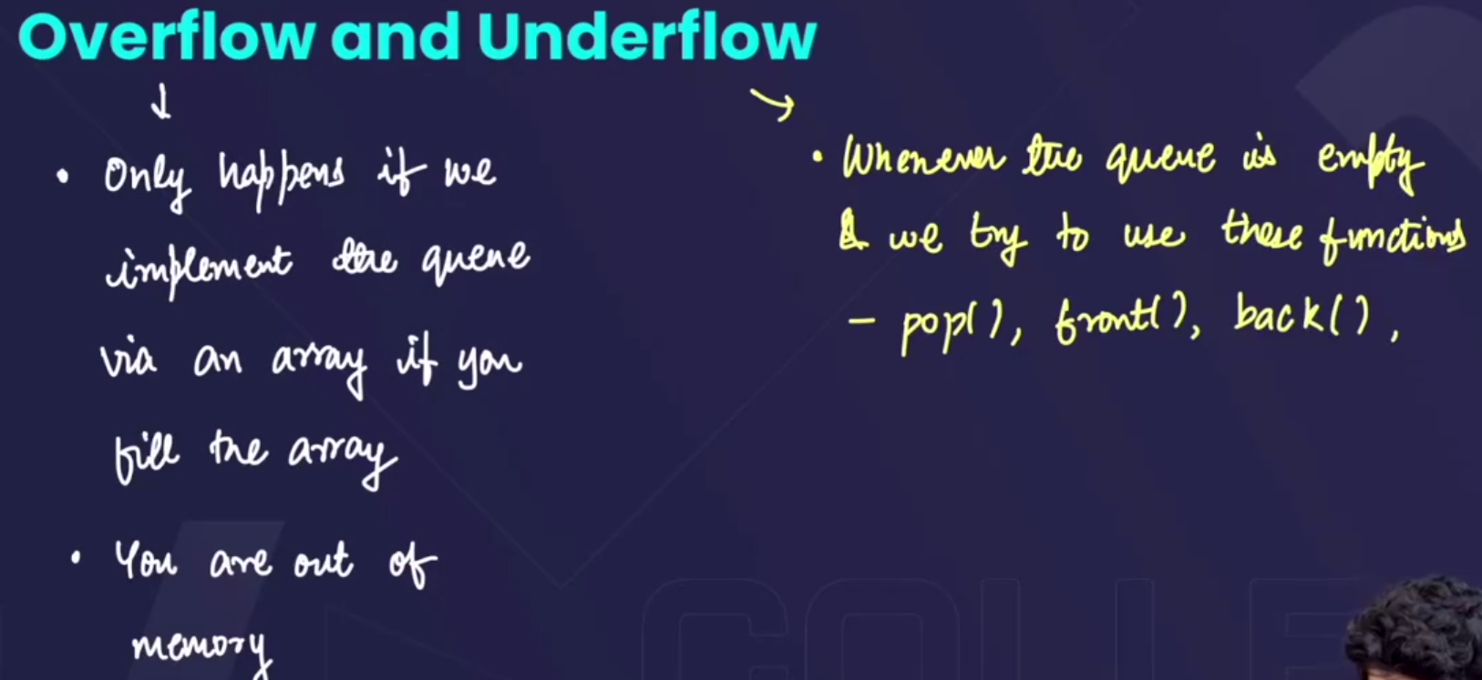

* Overflow in queue:
  + Happens only if we implement the queue using an array, and we full the array completely.
  + It also happens if our PC runs out of the storage.
* Underflow condition in queue:
  + Happens , when the queue is empty and we try to perform these functions: pop(), front(), back().

**# Function to display a queue:**

when we try print the elements of a stack then , hme pehle ek stack se element ko pop(), krna hota tha and then print krwaa k doosre stack m store krna hota tha, 🡪 then it used to take T.C=O(n) and also S.C=O(1).

But in queue , to print the elements of a queue, hm ek side se pop(), krke the print krwaa krke, then ussi queue k rear se push krwaa skte h, so that we don’t have to use any other queue(or any other data structure) 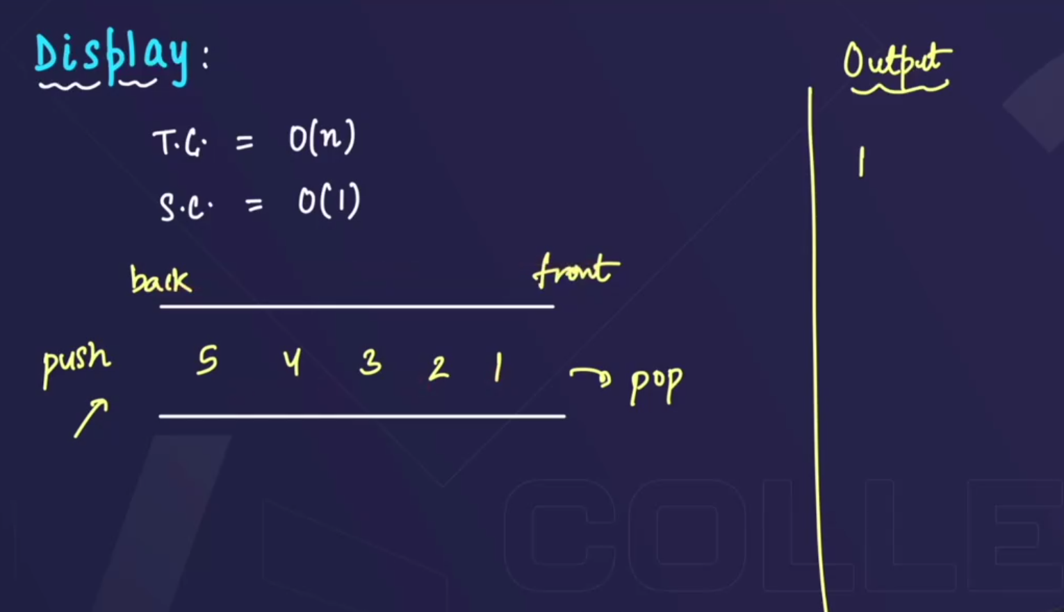🡪 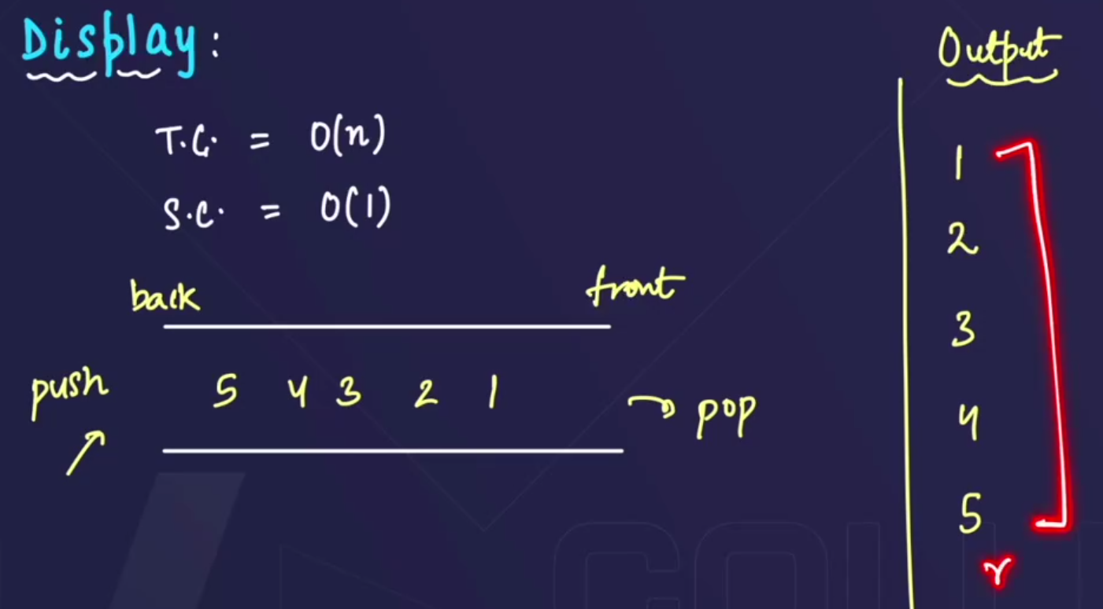

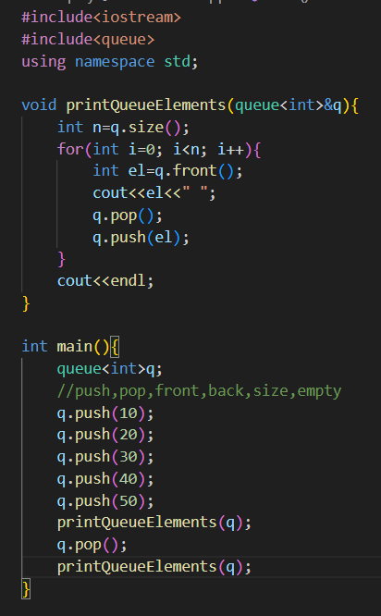 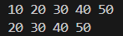

**# Function to display a queue in reverse order:**

* We cannot directly print the queue in reverse order , we need a stack to print the queue in reverse order.
* Process: pop() the elements from the front of the queue and push it into a stack then, again pop() the eleemnts from the top of stack and push it into the queue.

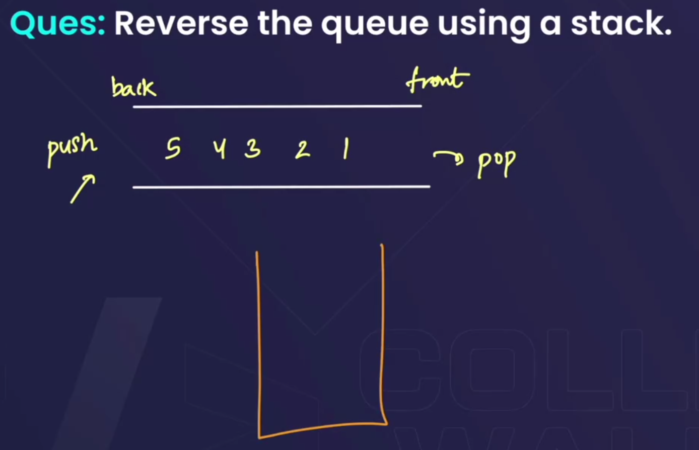🡪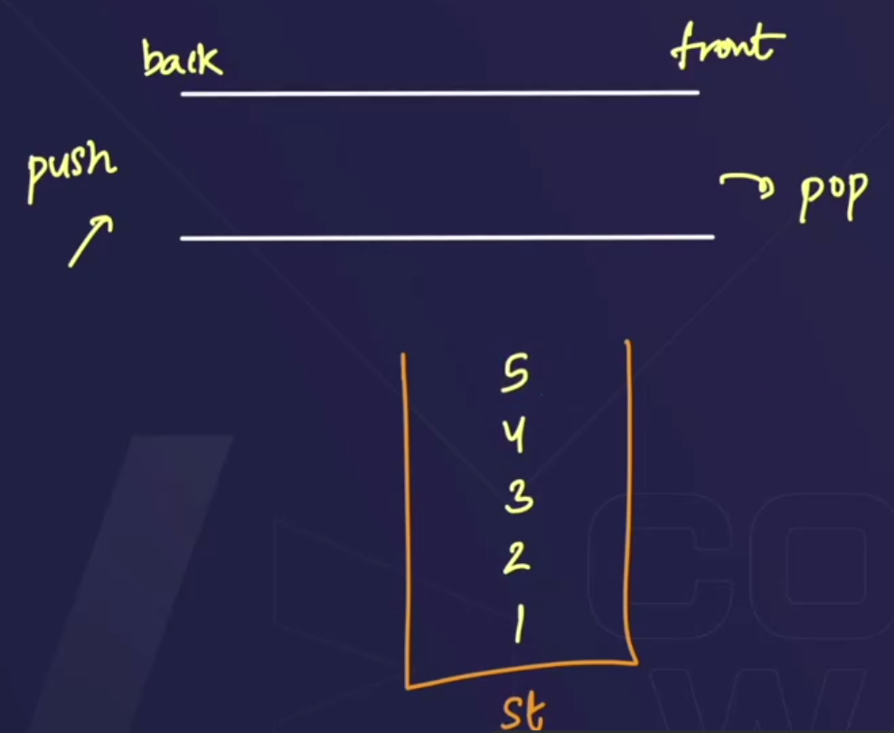🡪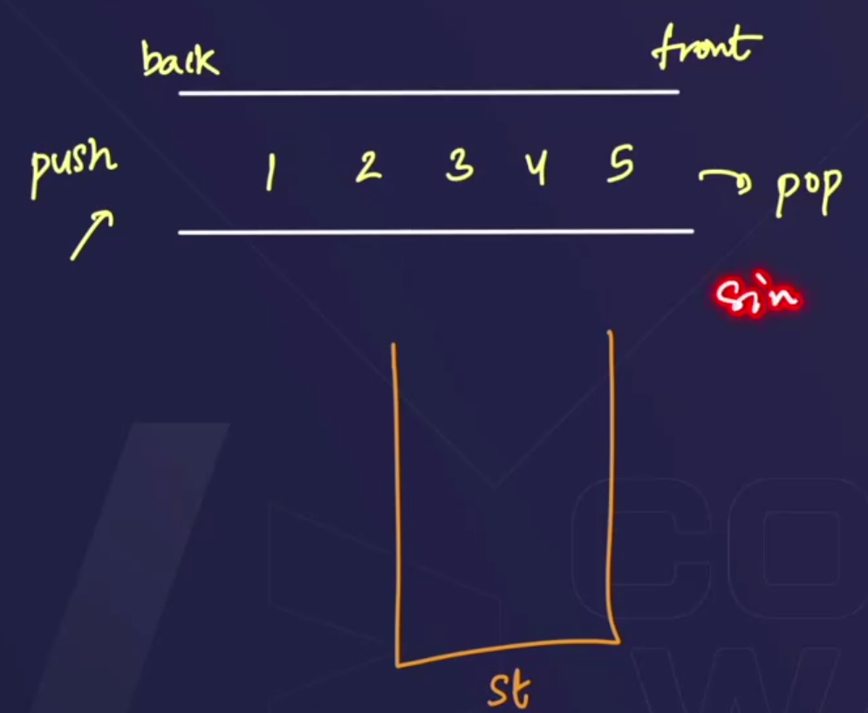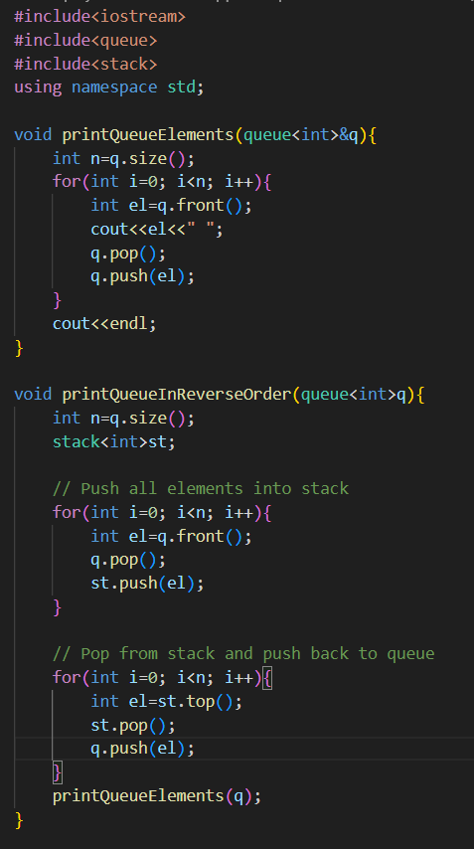

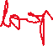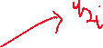

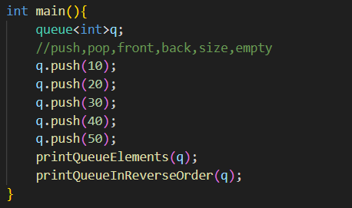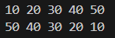

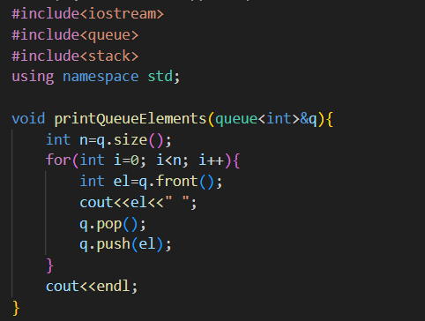

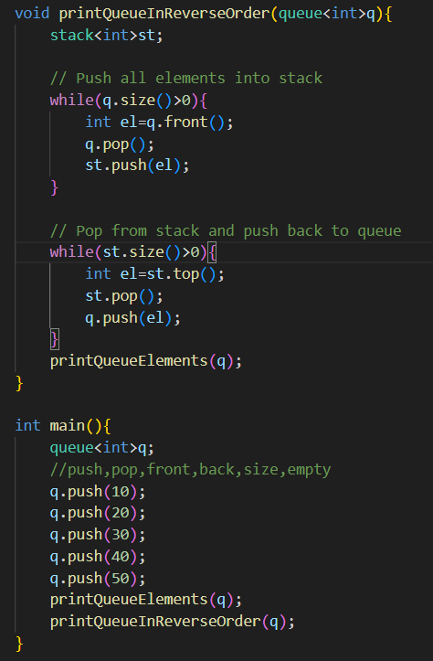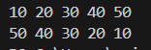

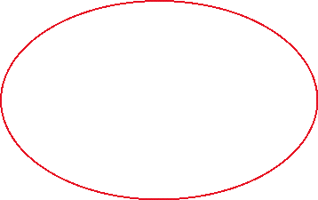

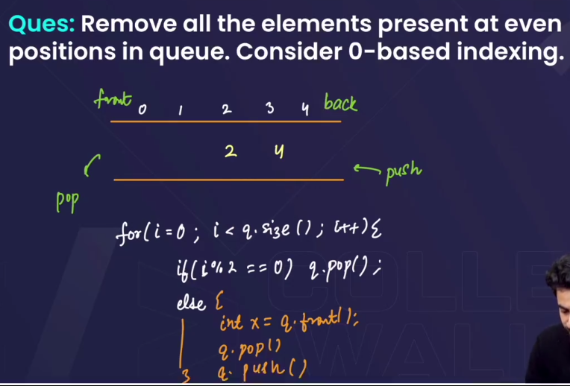

#Method 1

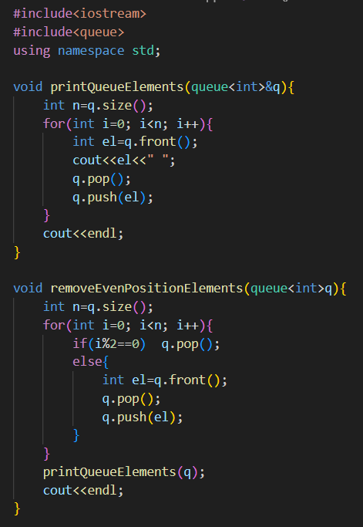



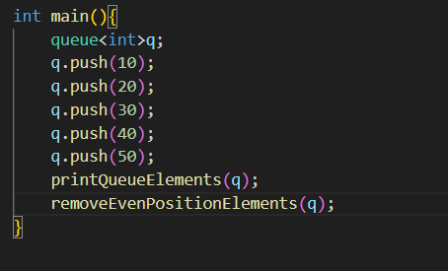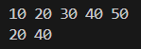

#Method 2

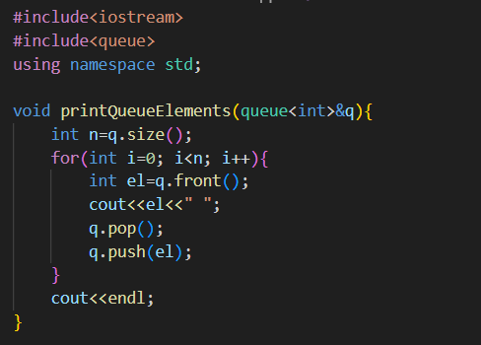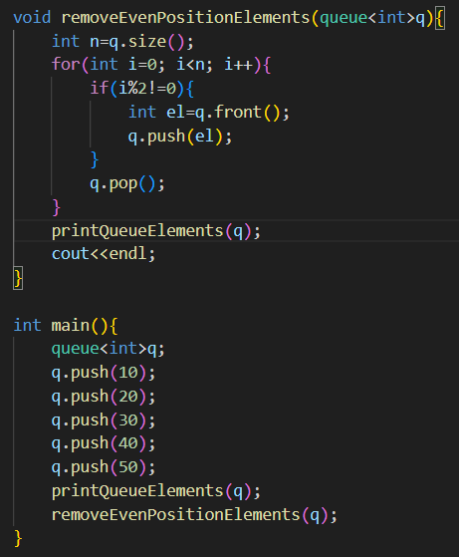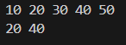

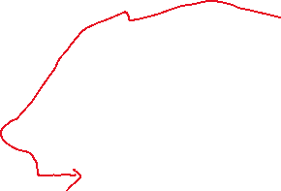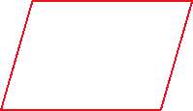

* Since we have to pop the elements in both case .

**# Implementing queue using array:**

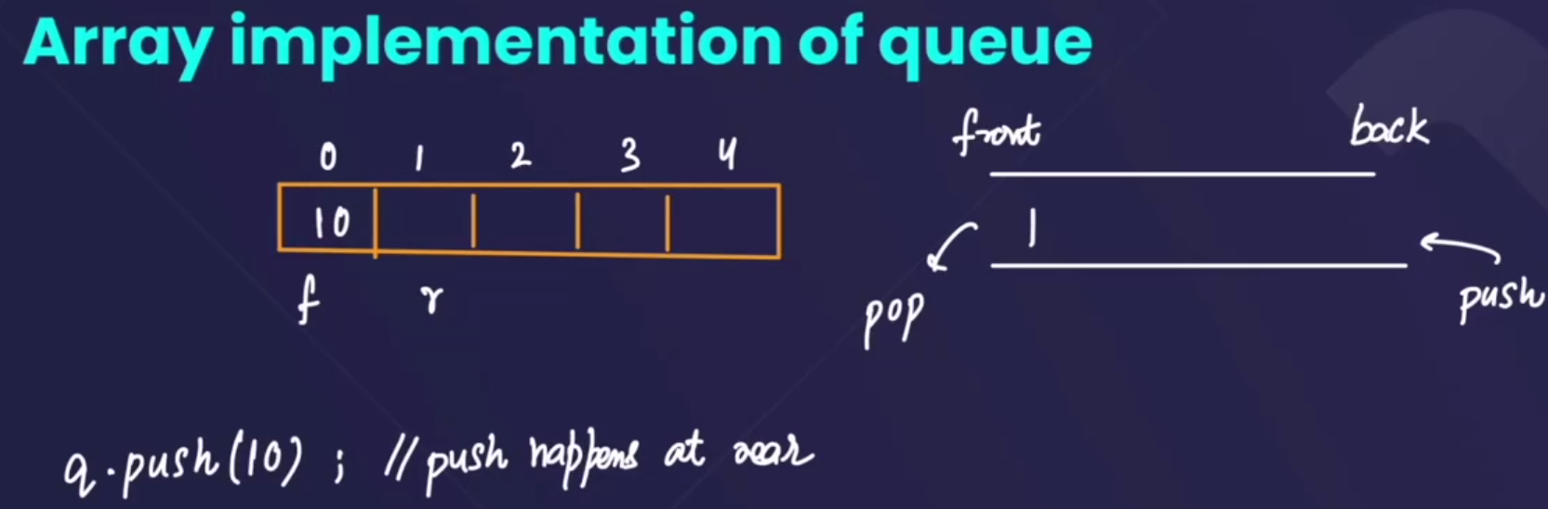

* 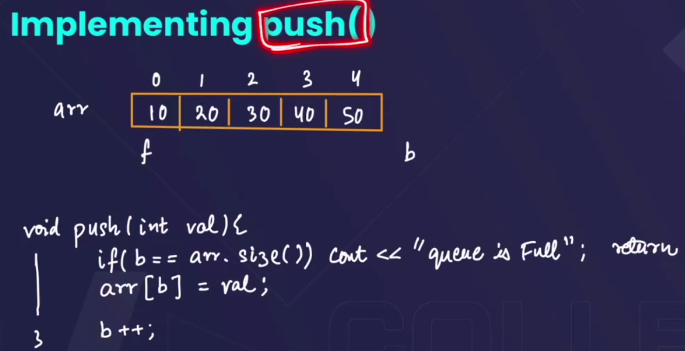🡪 define two variables **front** and **back** and put them on the 1st index of array, then put the value at the index where **back** is present then back ko aage badhaate jaoo **back++** and if array full ho jaaye then print that array is full.
* 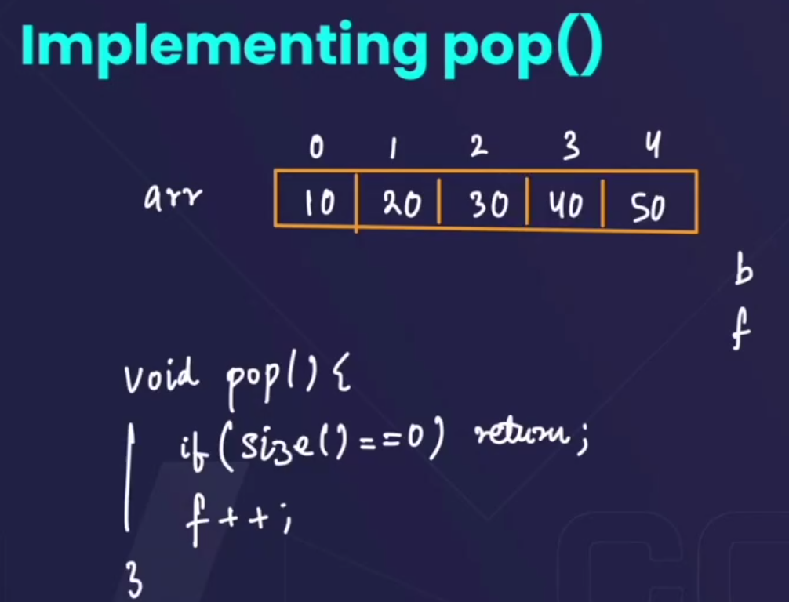🡪 isme kchh nhi krna h , bs front ko ek aage badha dena if pop(), krne ko bolega to.
* 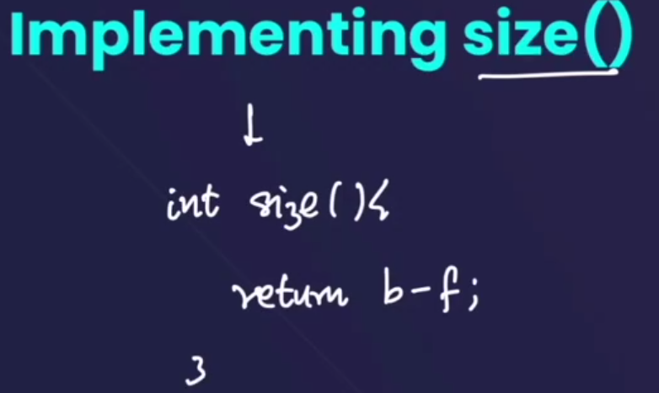🡪(back-front) will always give the size of the array.
* 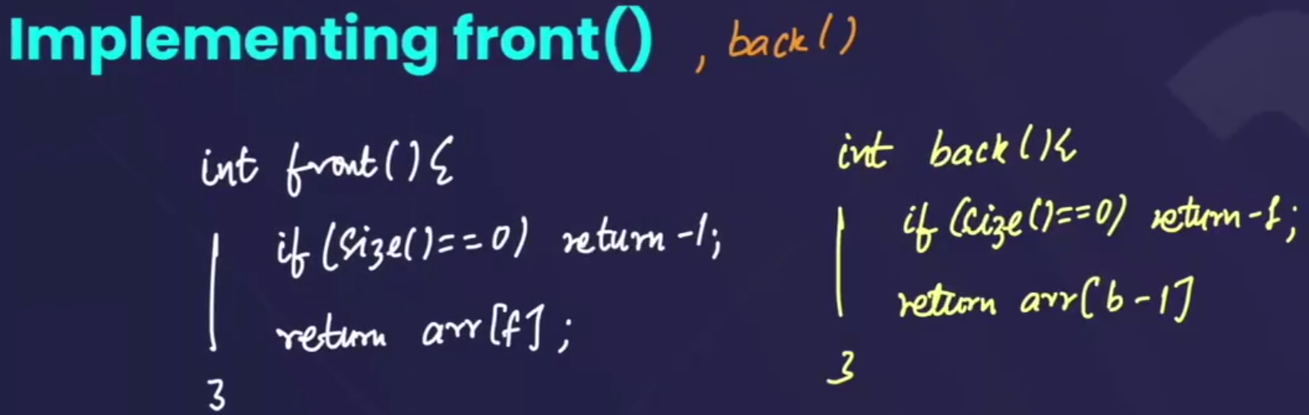
* 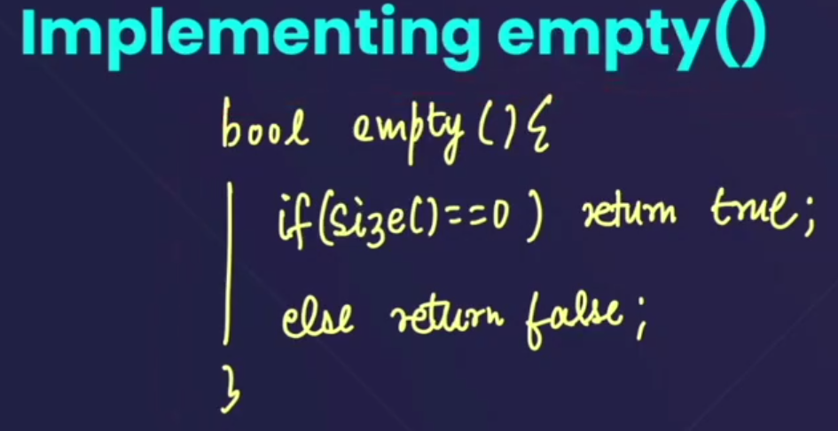
* 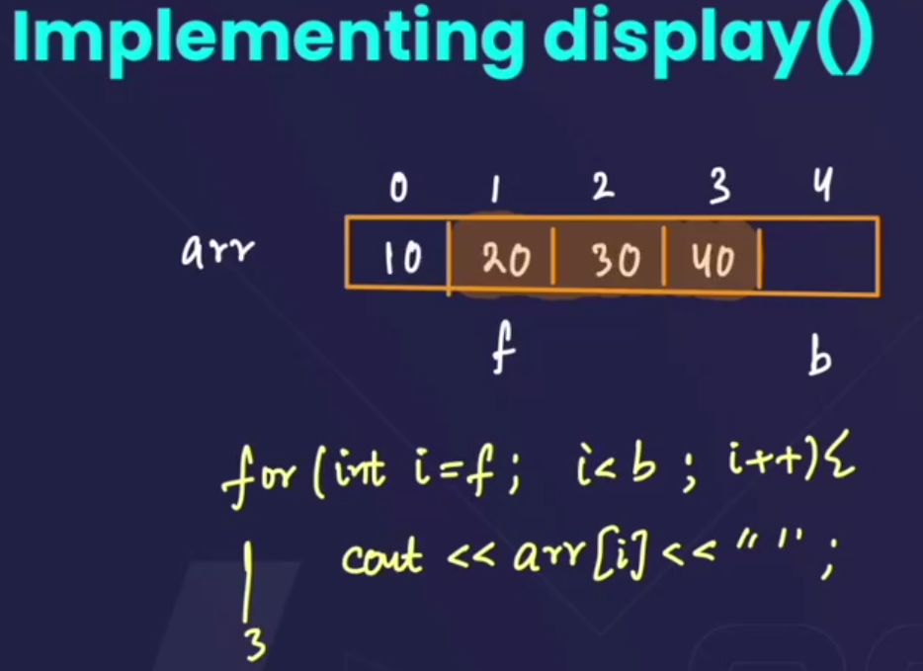
* 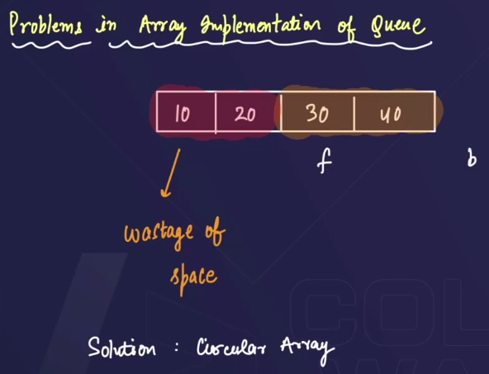🡪aage se pop() krne k baad bhi size() full dikhaane lgta h, so this is a problem in array implementation of queue.



* The solution to this is a circular queue.

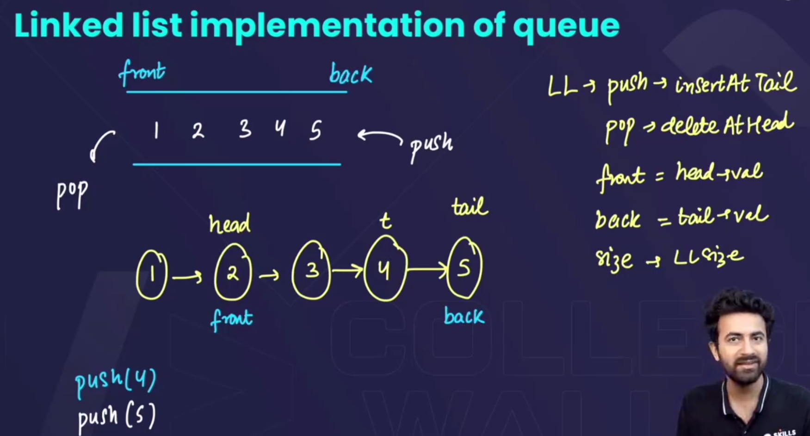

* 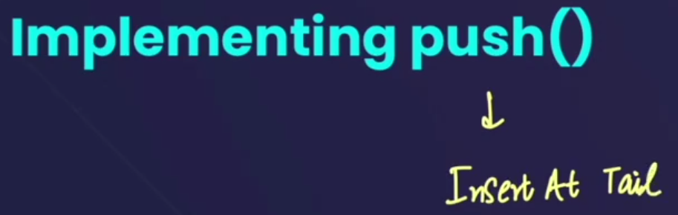
* 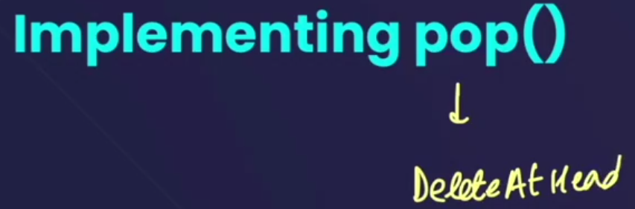
* 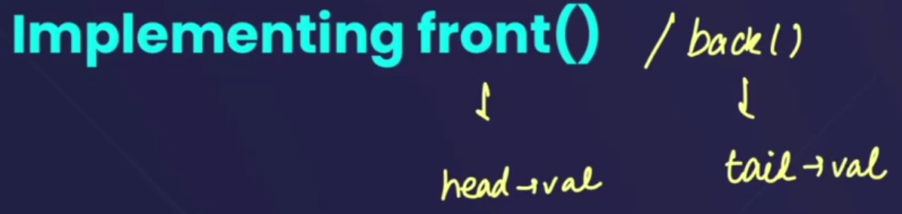
* 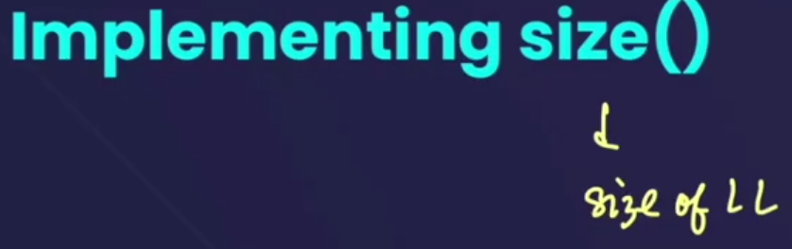
* 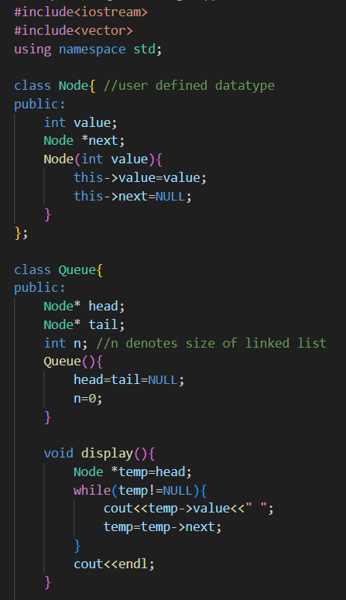

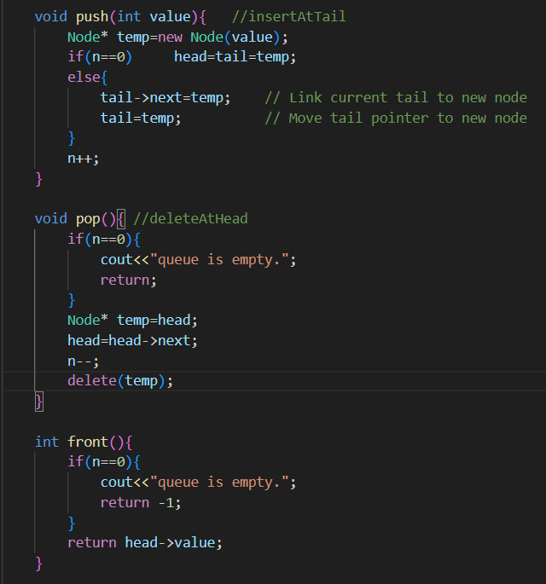

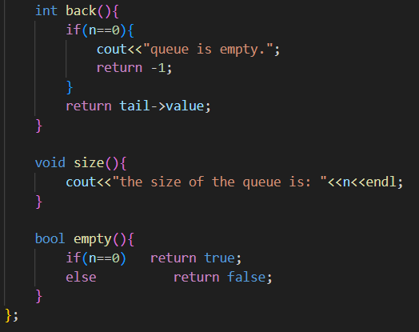

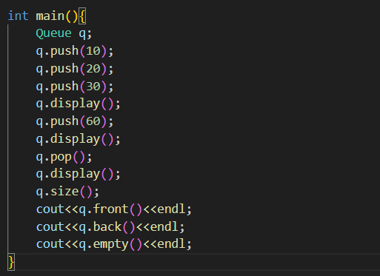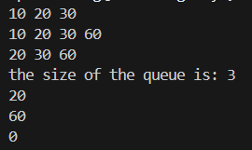

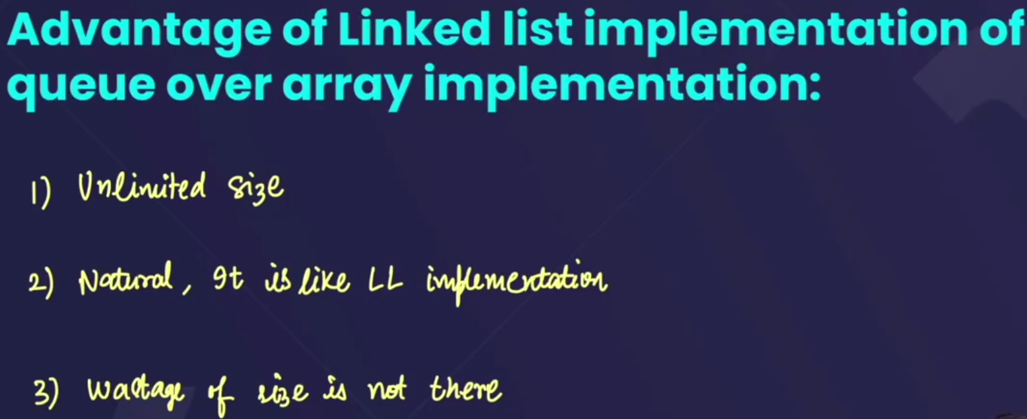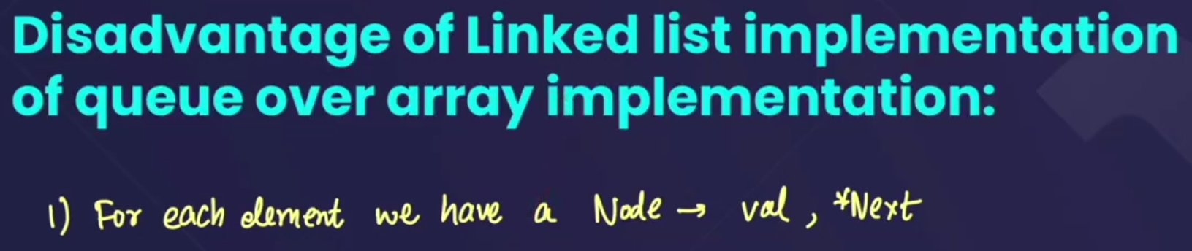  
=>there is only one disadvantage of linked list implementation of queue, i.e, for each element we have a node that contains two values -> **value** and **\*next**.--> that fills the storage.

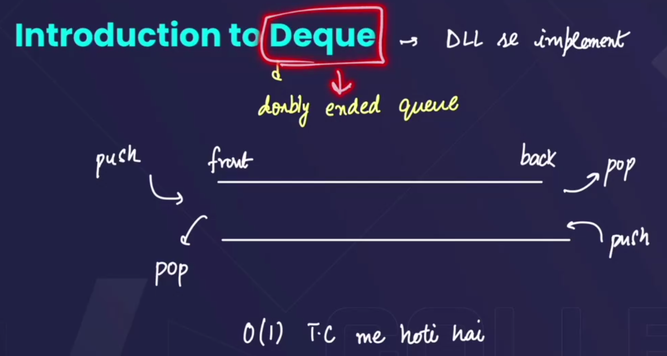

* Also called **doubly ended queue**
* In doubly ended queue, we can perform push and pop from both sides.
* We can also implement dequeue using array and linked list(doubly linked list).

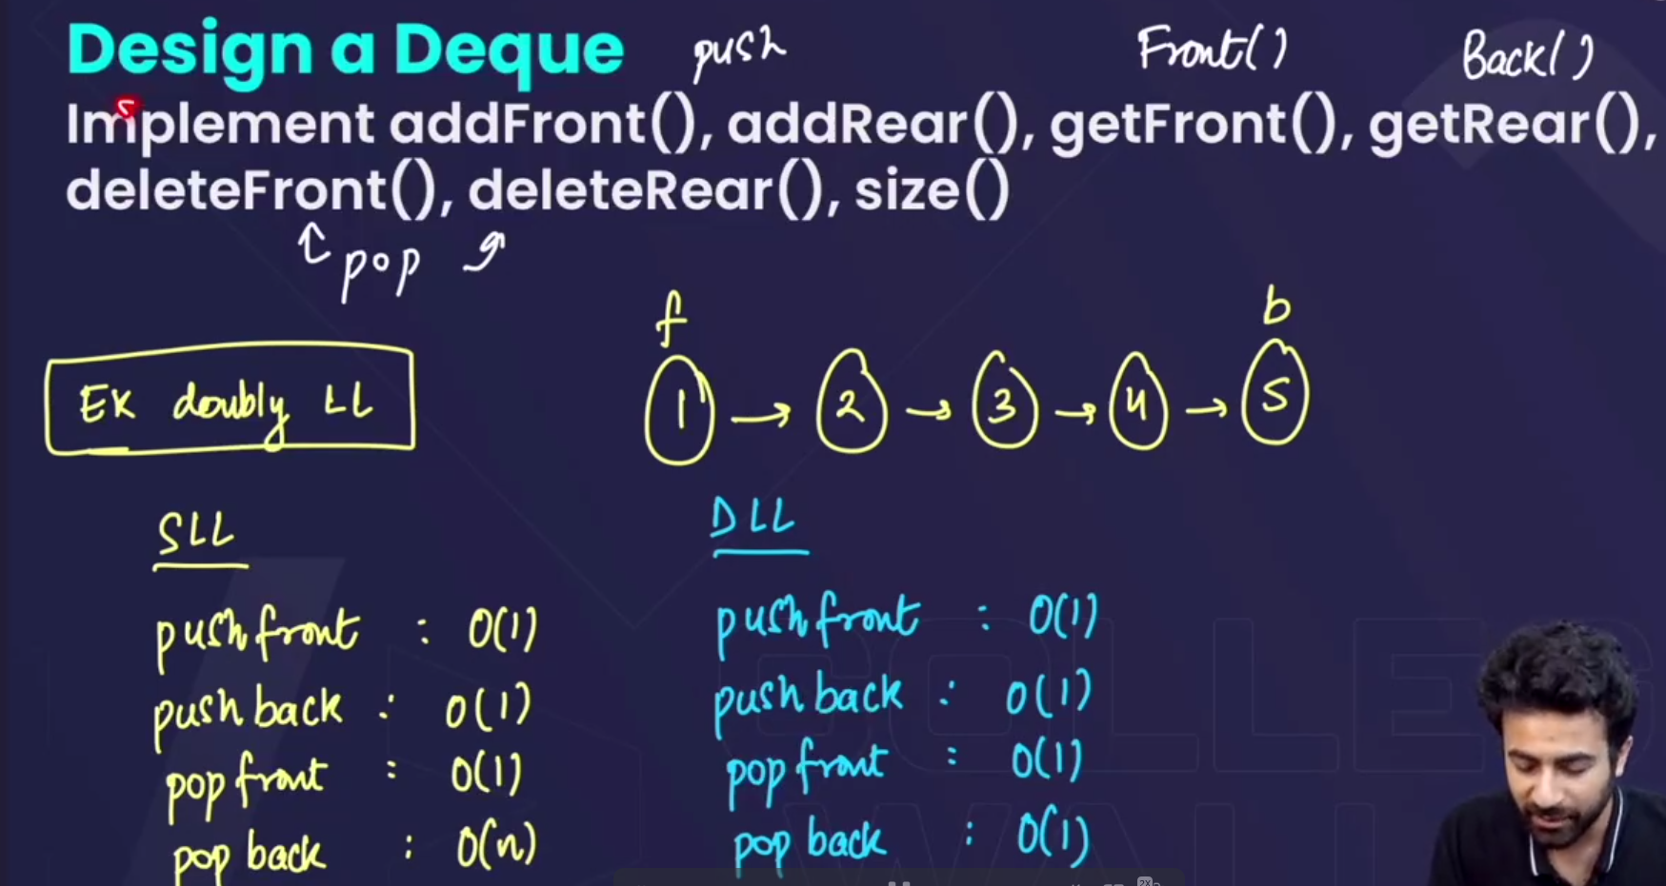🡪in singly linked list there is a disadvantage that to pop() from back we have to traverse from starting to end to delete🡪so the time complexity becomes O(n) , but in doubly linked list we can directly pop() 🡪 so the time complexity becomes O(1).



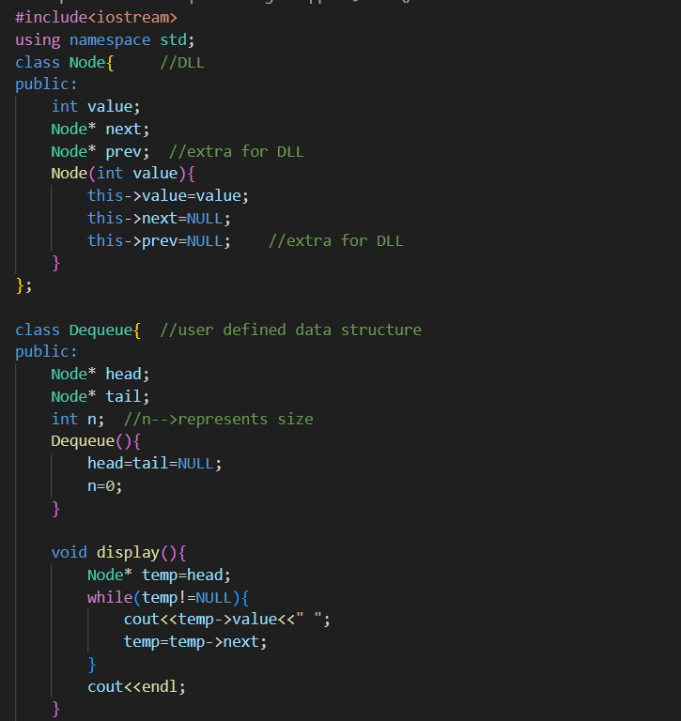 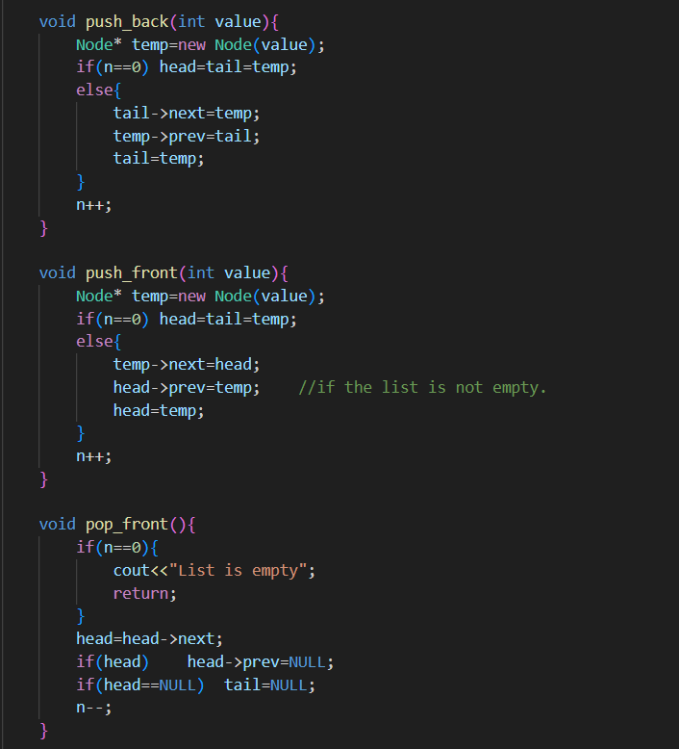 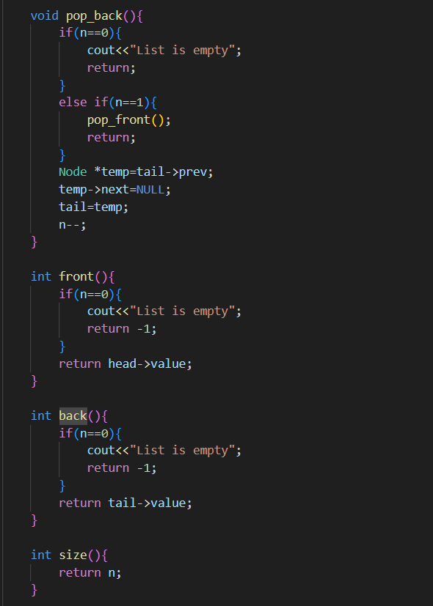 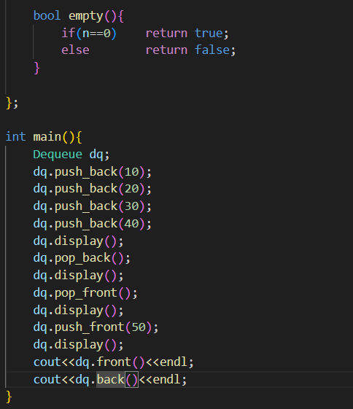 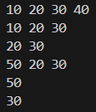

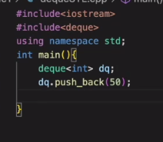🡪we can also use **inbulit deQueue**.



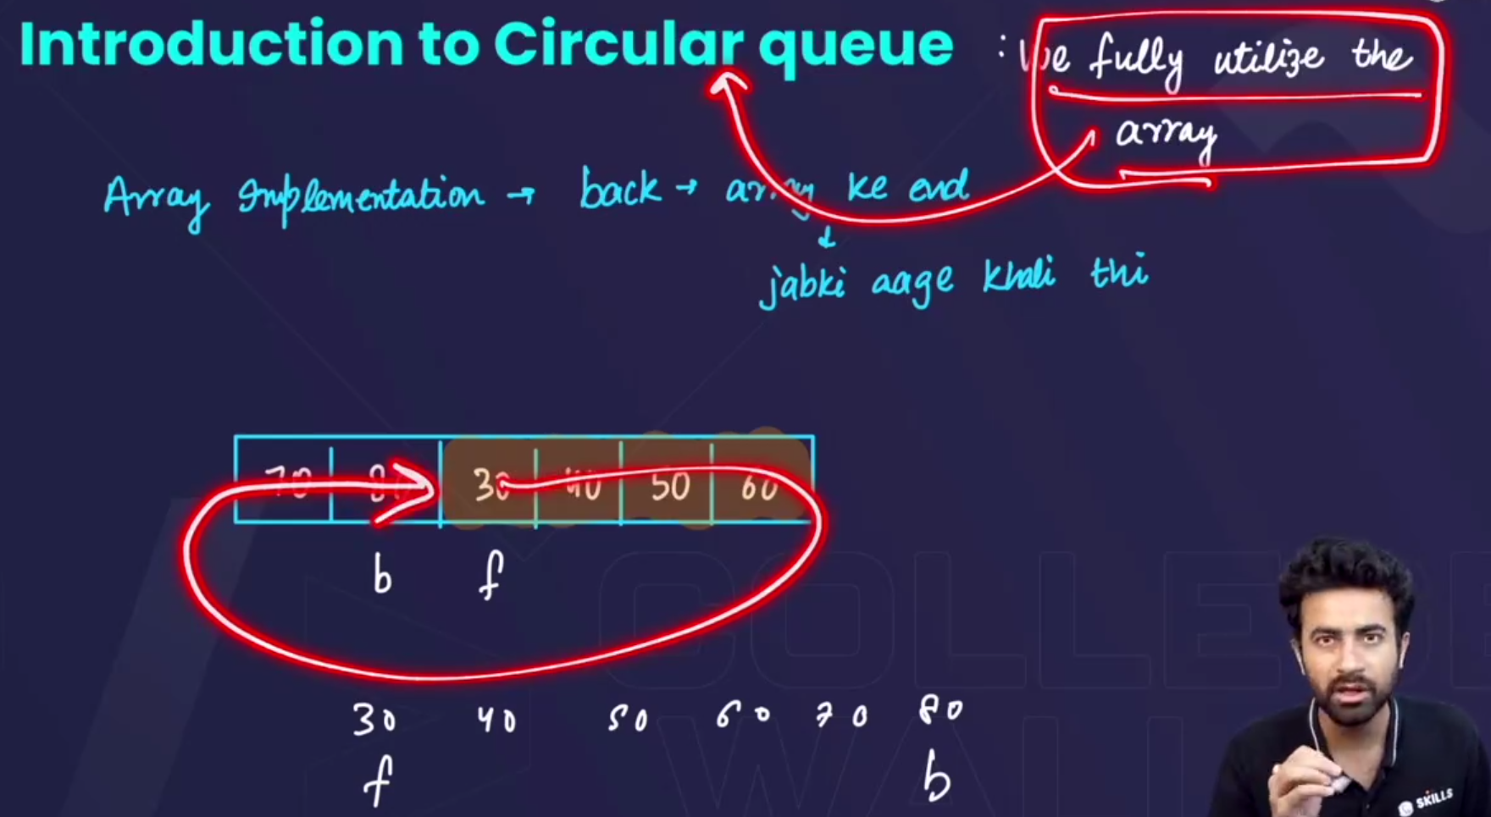

* In the array implementation of queue, usme ek disadvantage tha ki, hm jb pop(), krte the, then space khaali to ho jaata tha, but hm usko reuse nhi kr paate the🡪that results in the wastage of space , this is why we use a circular queue and fully ustilize the array.
* 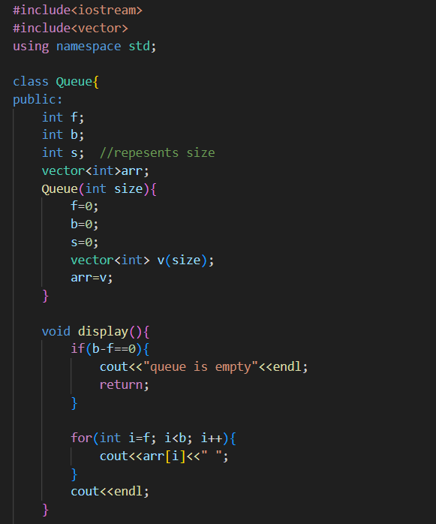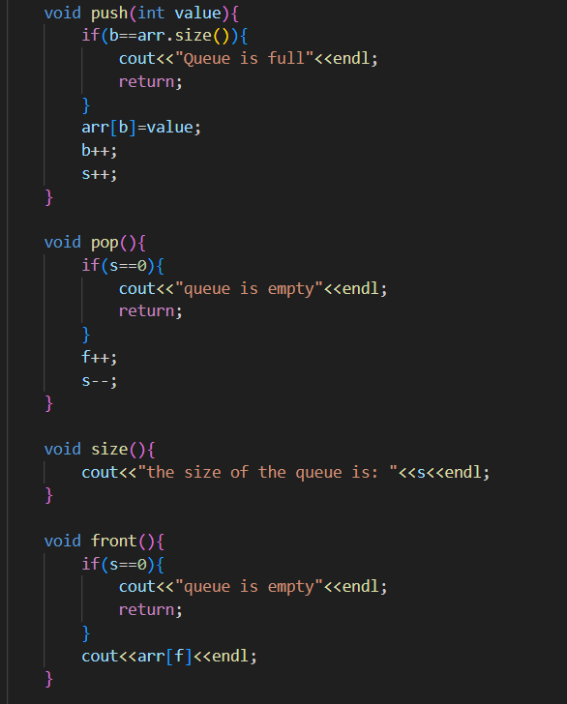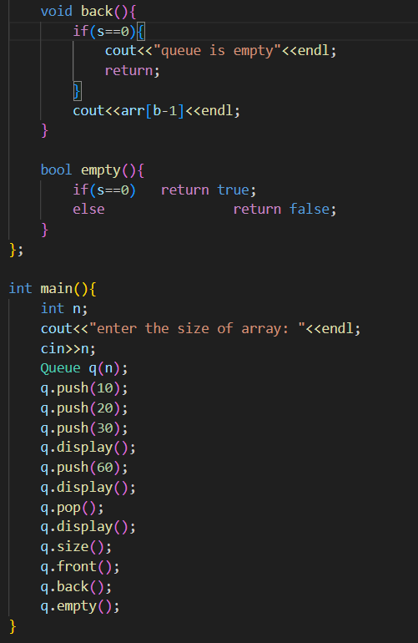

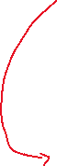

Here we just maintained a size variable, and the rest things are as same as **implementingQueueUsingArray.**

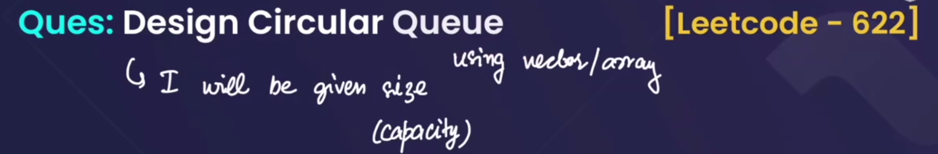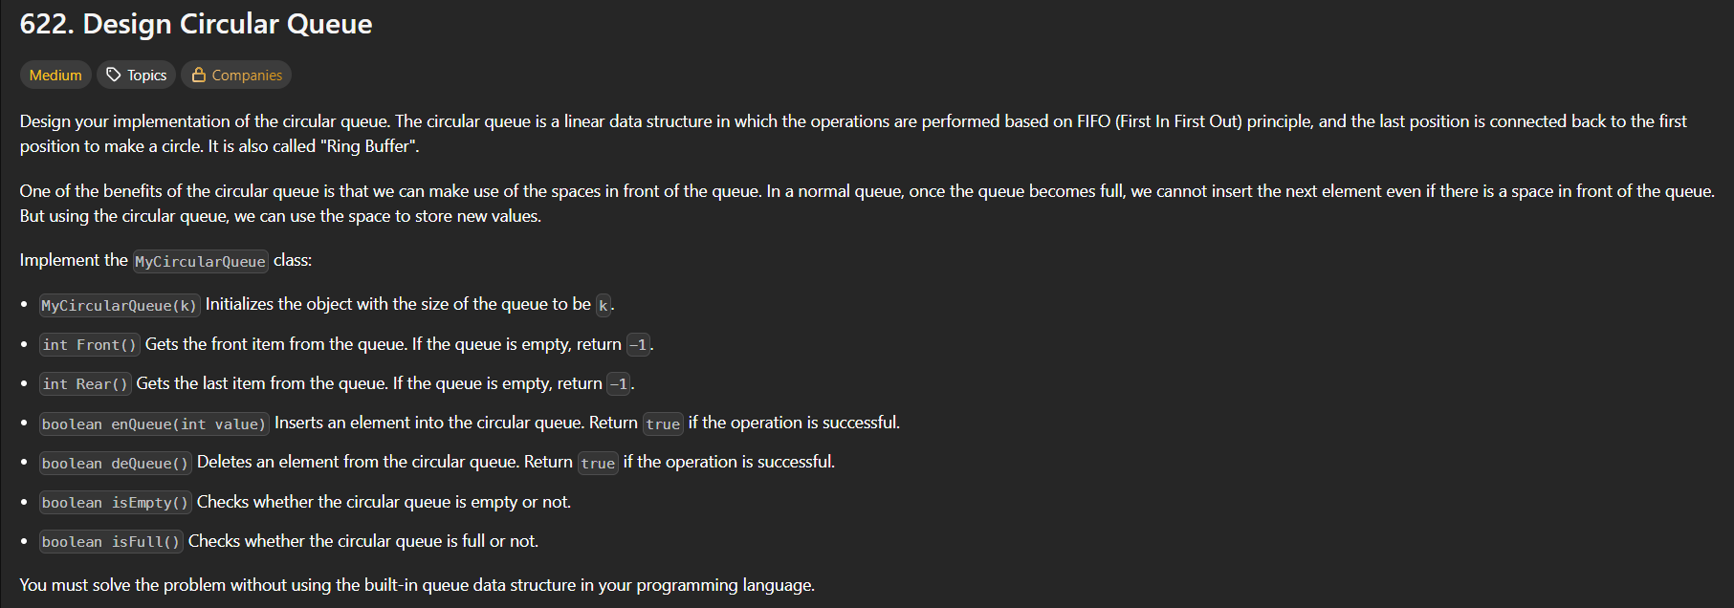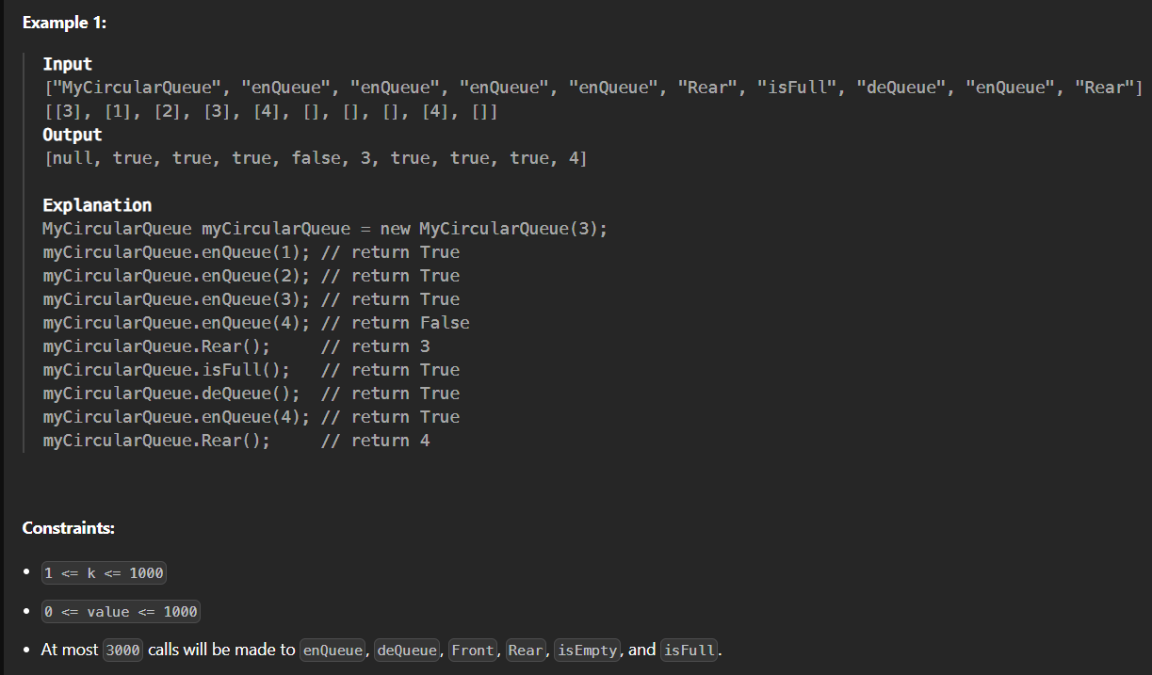

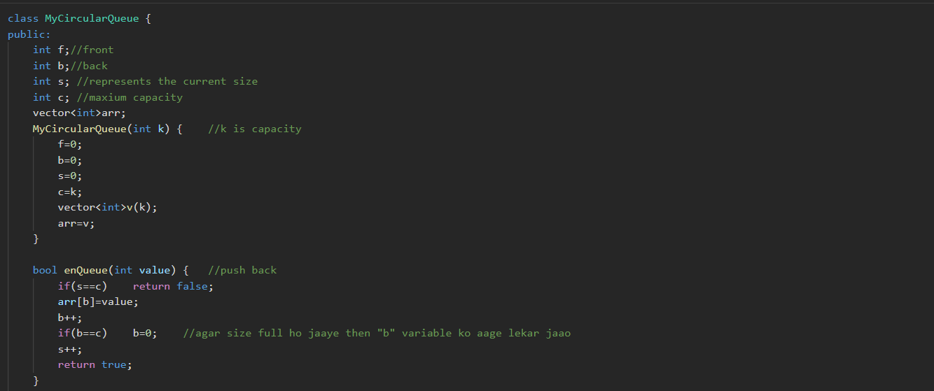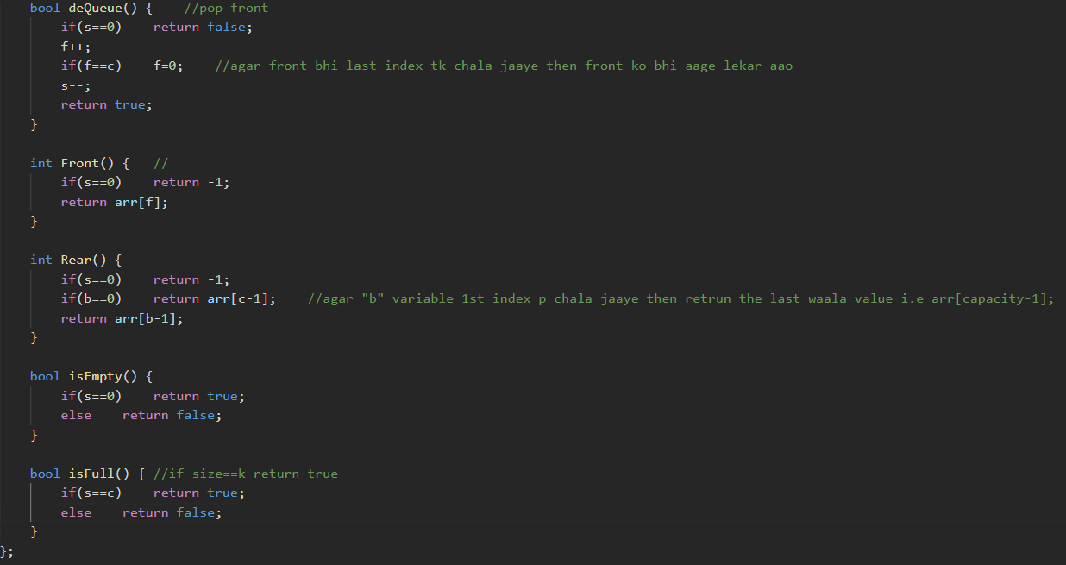





* We have implemented the question of reversing a queue using a stack.

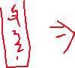

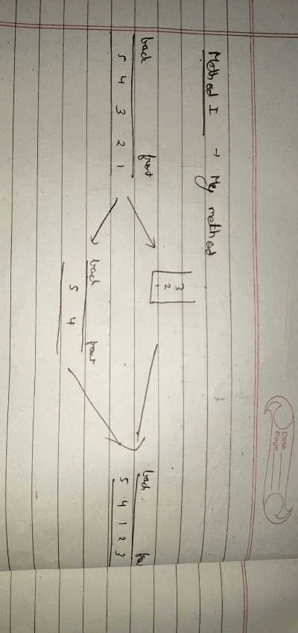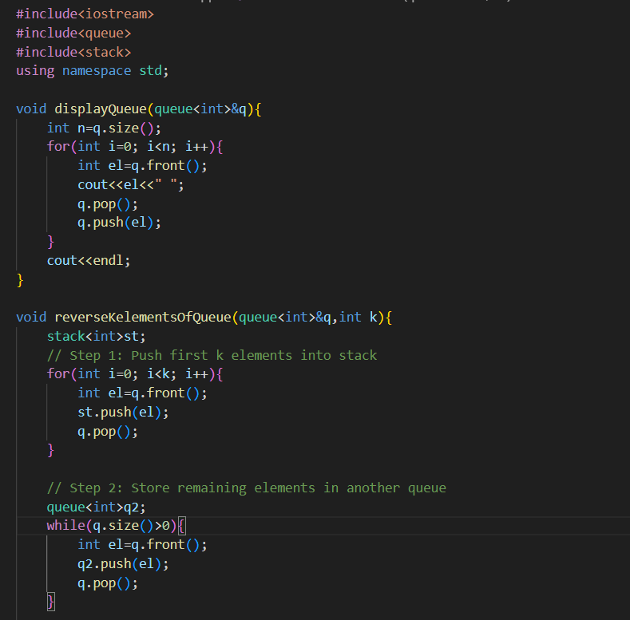

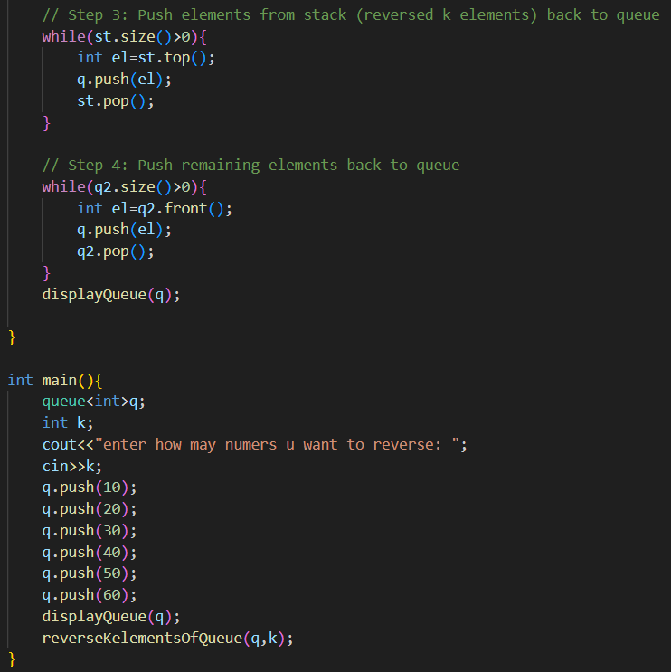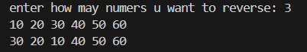

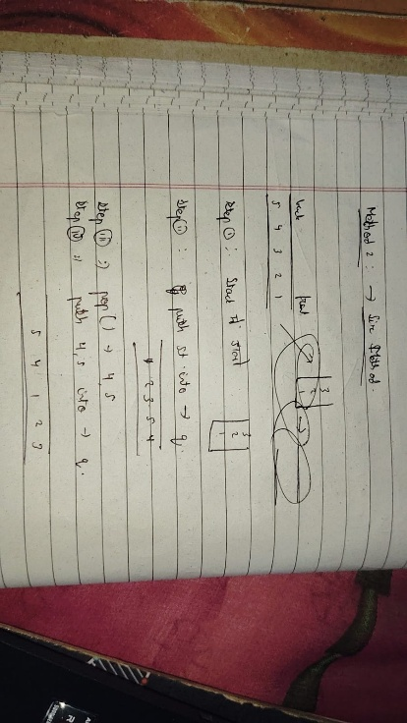

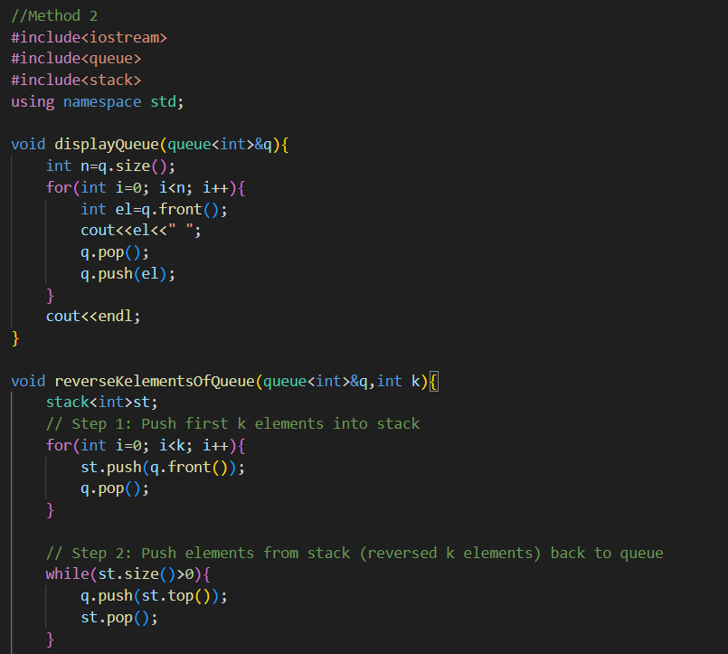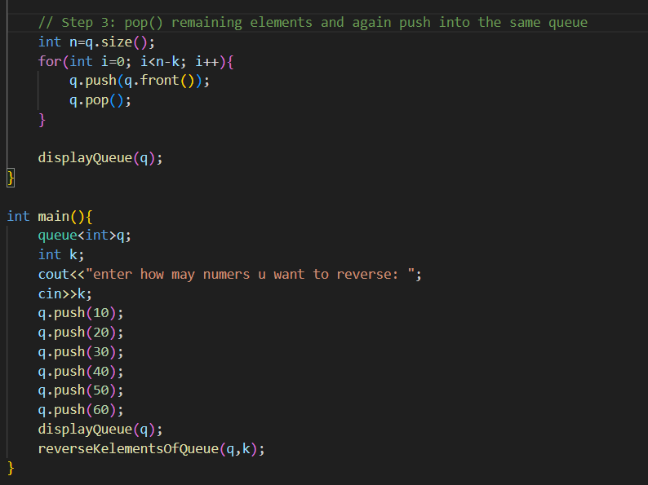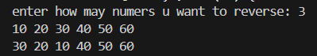

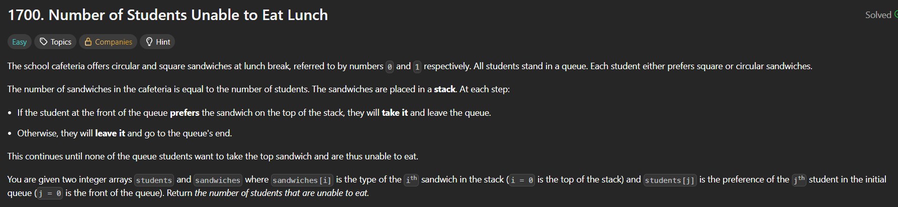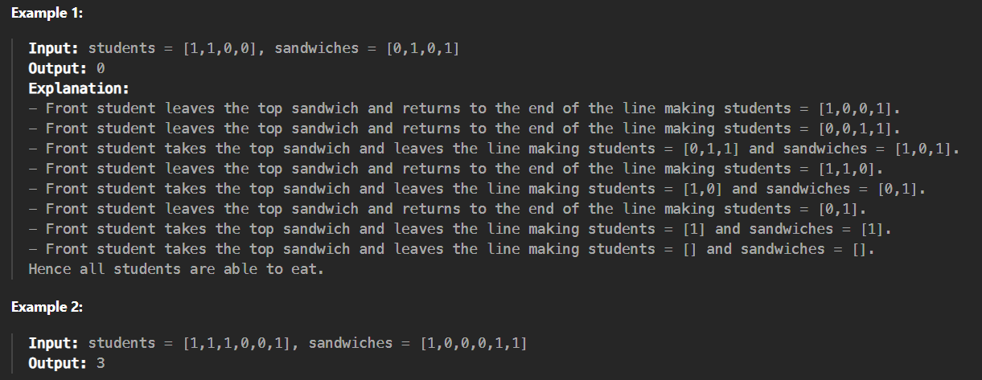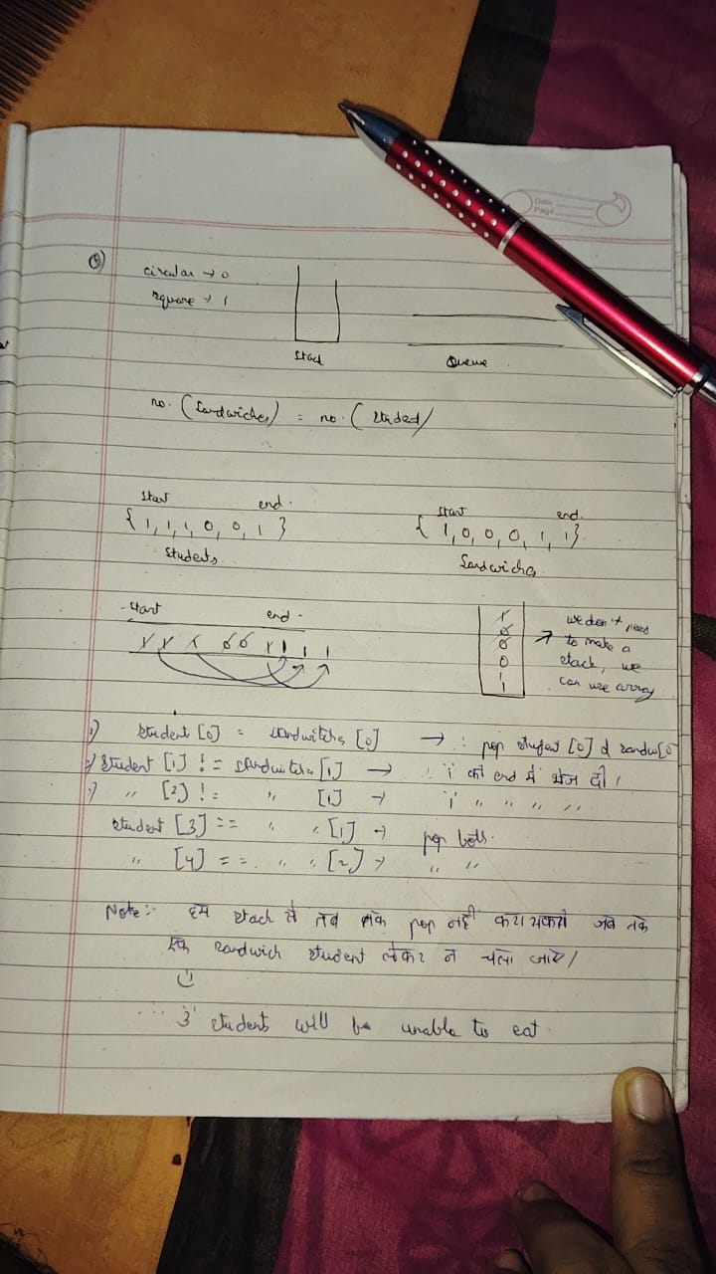🡪 approach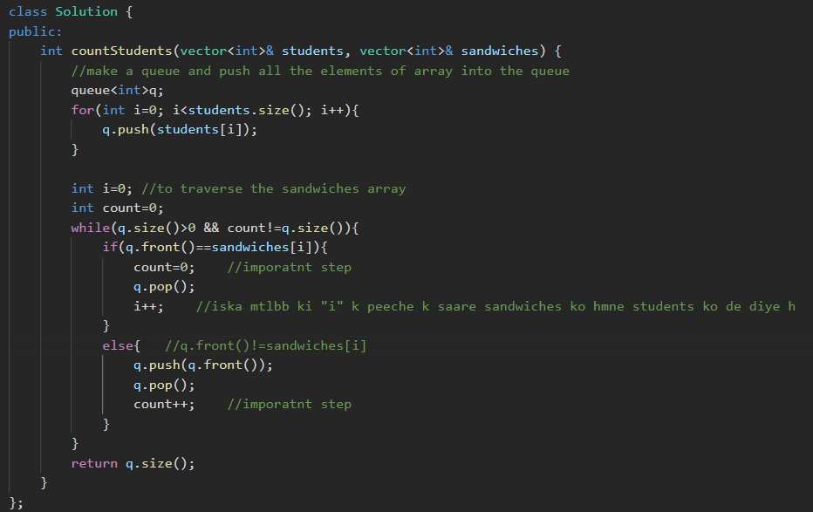



* DRY run: 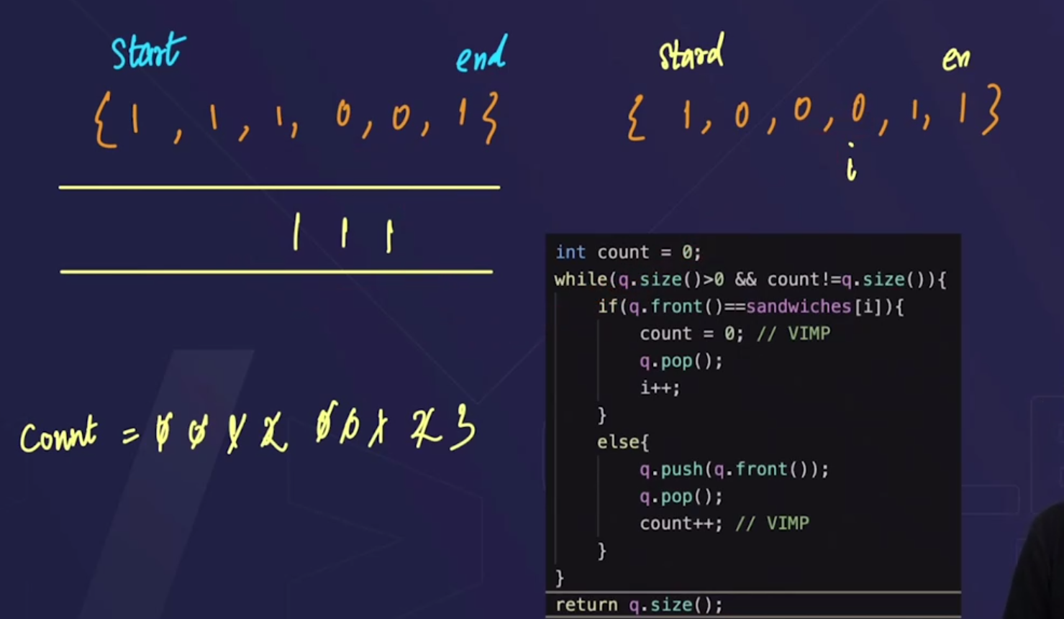

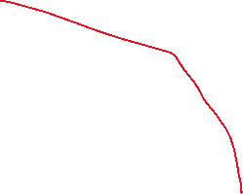

* count variable helps to not to go into the infinite loop.

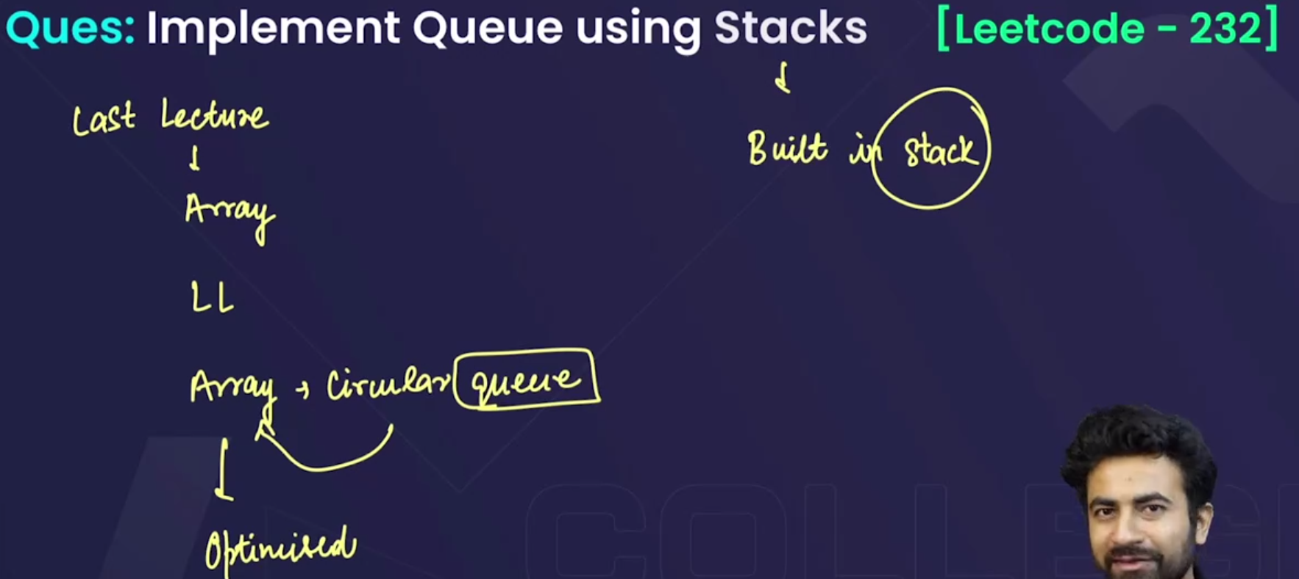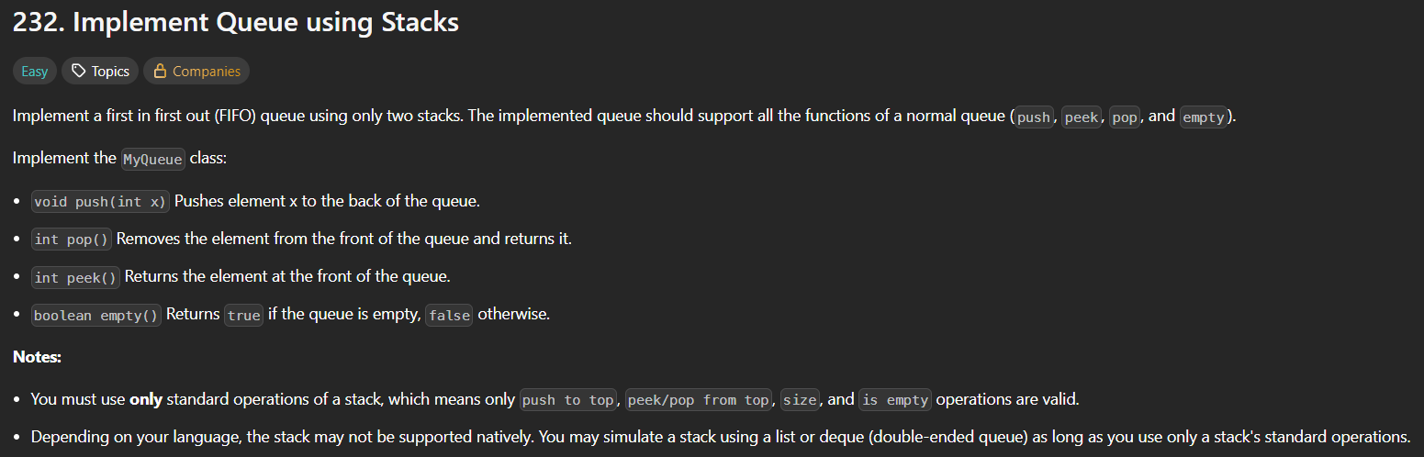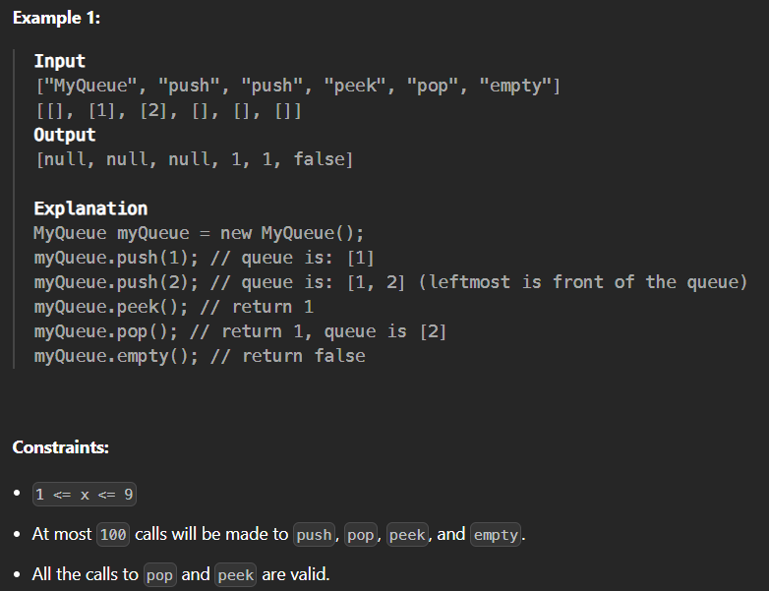

* Hint: use 2 stacks

Method 1: Push efficient approach

* 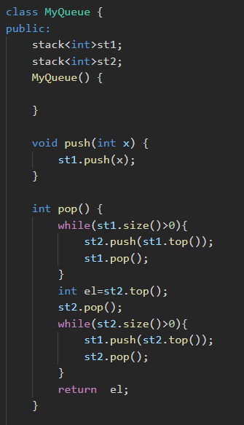

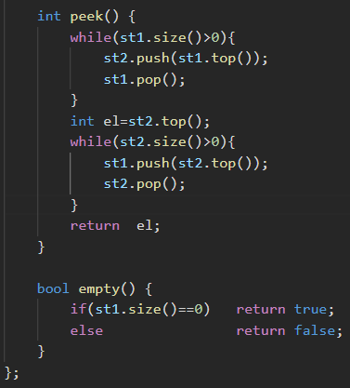

Method 2: Push efficient approach

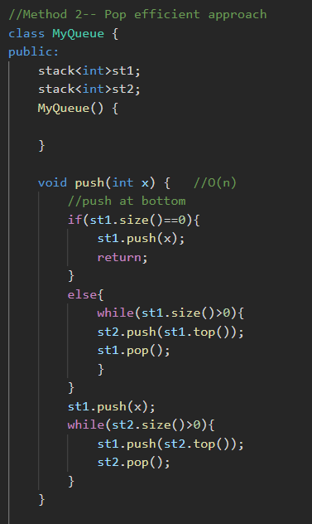

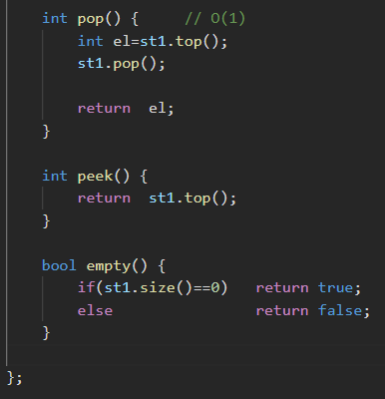

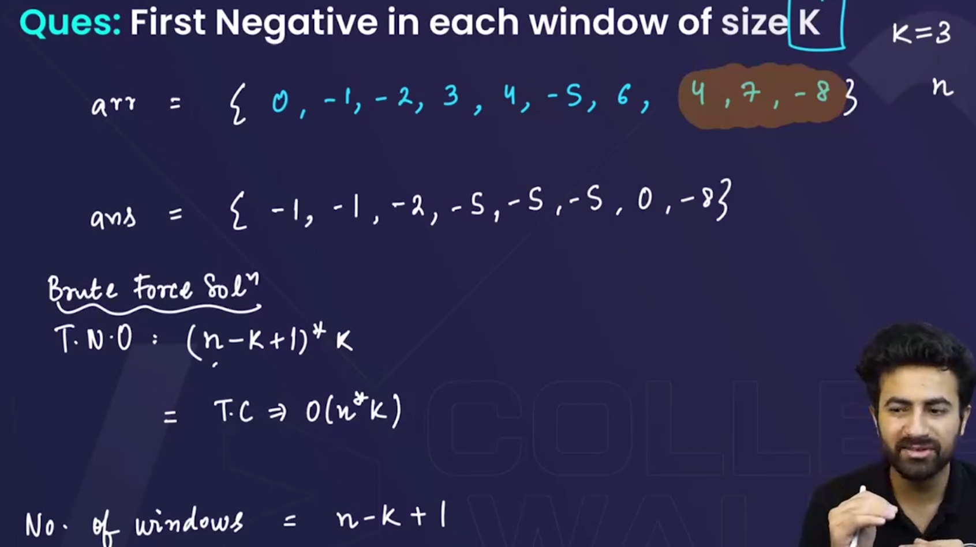

Method 2: Using Queues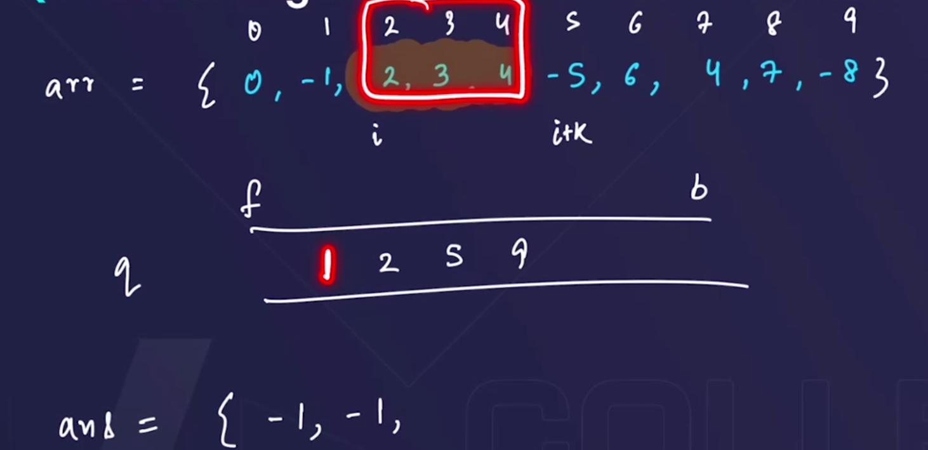

* Step 1: store the indices of the negative elements of the original array inside the queue.
* Step 2:Now to make the answer array: travel from start ,
  + Check whether the 1st element of queue lies in the window or not
    - If lies then push it into the answer array.
    - Else : put 0 in the answer array.

#My method # Sir’s Method

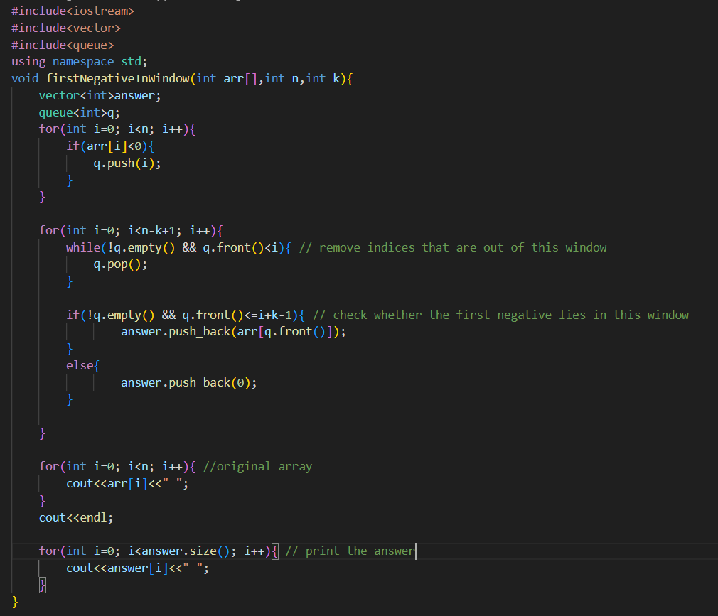 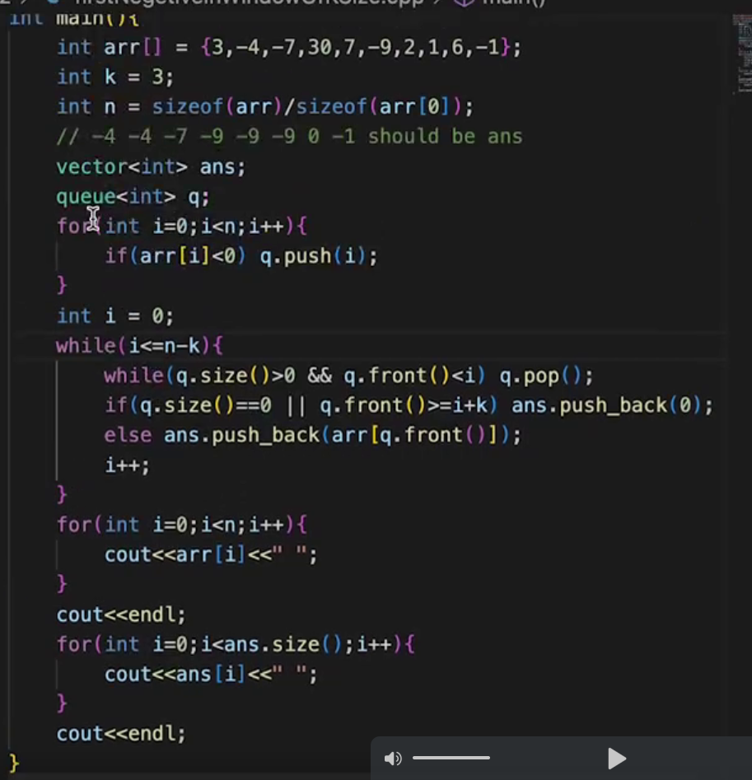

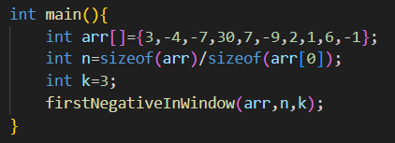

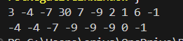



* Method 1 using Stacks—but I was unable to run this:

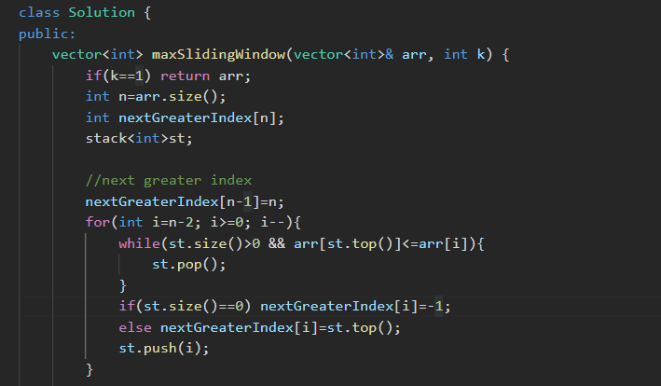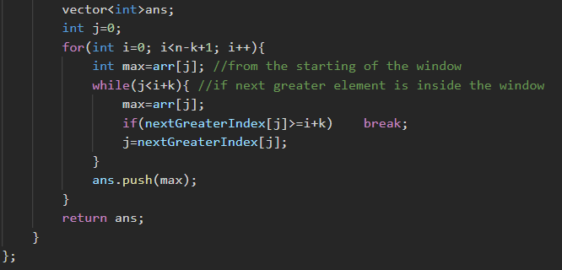

Method 2: using dequeue: we will make a monotonic dequeue 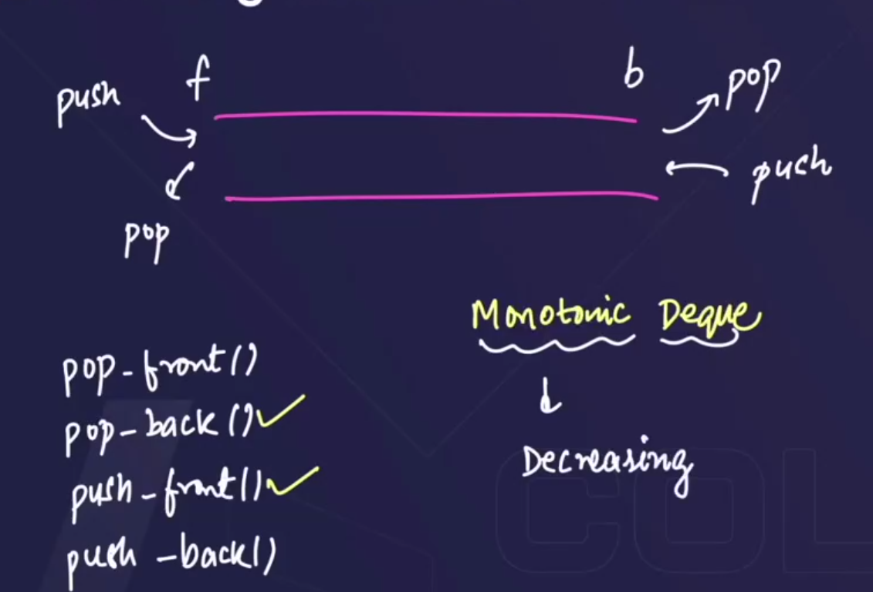

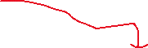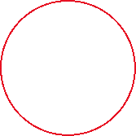

* We will use a different new features of dequeue:

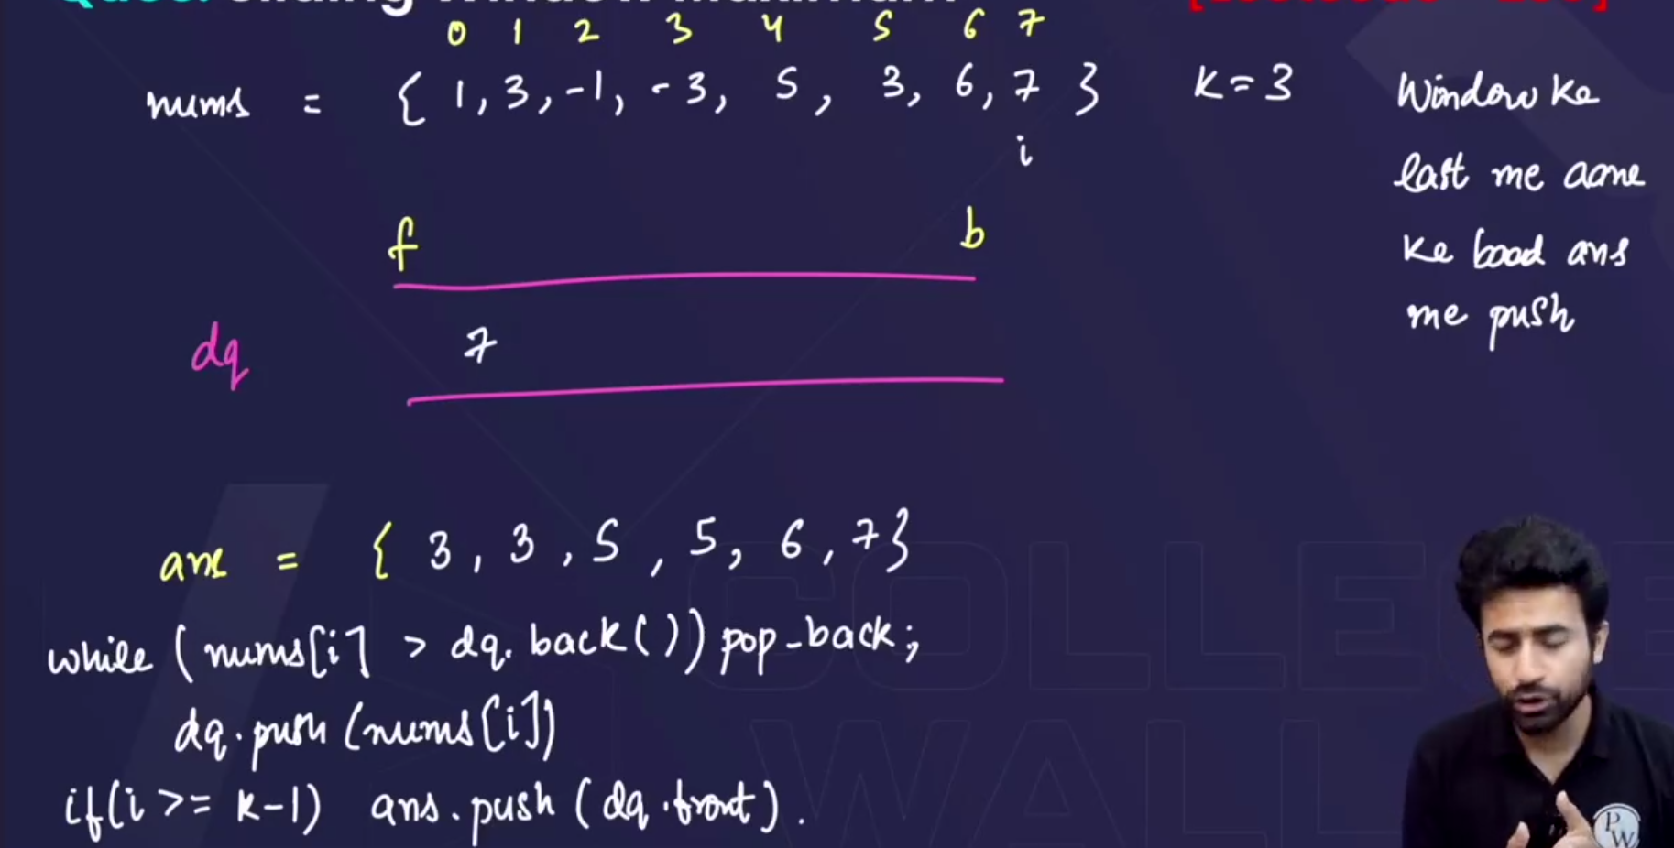



* It gives error in some cases , so we will use indices.

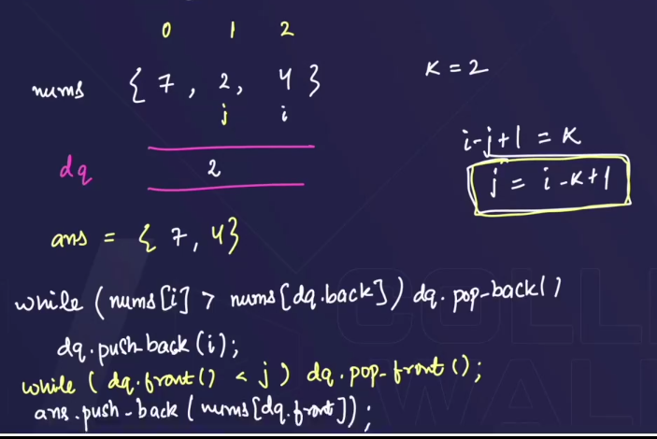

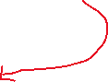

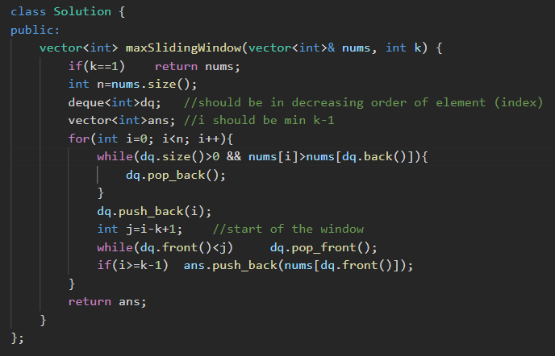

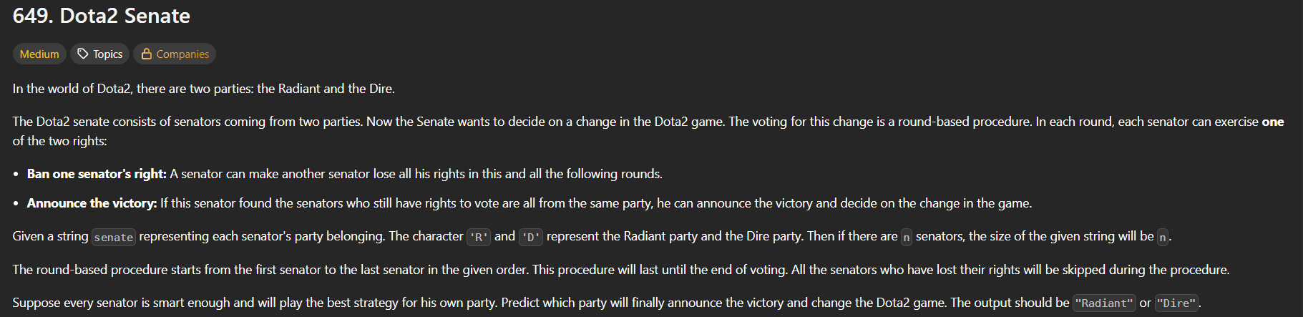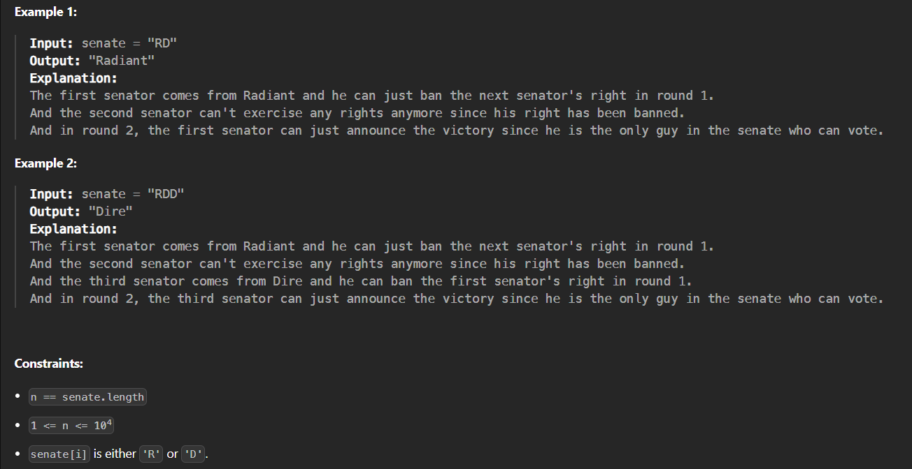

**Problem story:**

* There are **two parties** in the senate:
  + **Radiant** (R)
  + **Dire** (D)
* They are sitting in a line (like a string "RDDRRD...").
* The voting happens in **rounds**.

In each round:

1. Senators take turns **in the given order** (left to right).
2. When it’s a senator’s turn:
   * If they are still active (not banned), they can **ban** one senator from the opposite party (the banned senator loses all future turns).
   * Or, if only their party remains, they **win**.
3. After the last senator in the line takes a turn, the next round starts again from the beginning (with the remaining active senators).

The game continues until all senators from one party are banned. The party with remaining senators **wins**.

**Example:**

Input: "RDD"

Step 1:

* **R** goes first → bans one **D**. String becomes "RD" (the second D is banned).

Step 2:

* **D** goes → bans one **R**. String becomes "D".

Now only **Dire** remains → **Dire wins**.

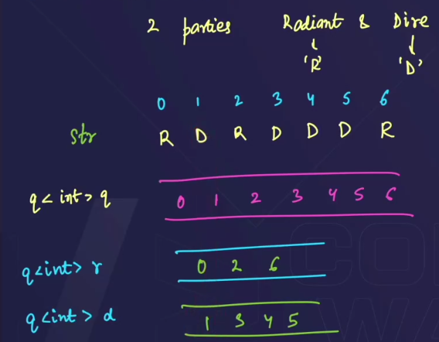🡪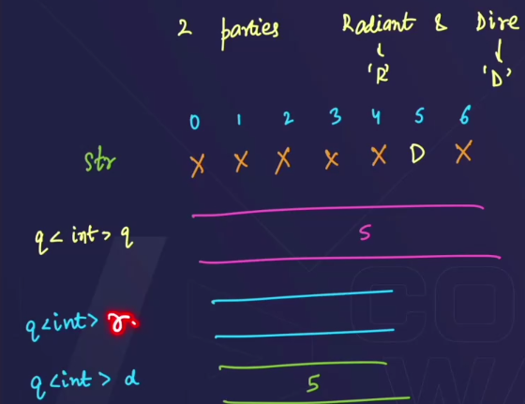

* Make 3 queues ,
  + 1st : q => stores the indices of the string.
  + 2nd: r => stores the indices of “R”
  + 3rd : d=> stores the indices of “R”
* Travel in the 1st queue(q) , check if the 1st element of “q” is “R” or “D”,
  + if it is “R” then :
    - check if the queue(d) is empty or not 🡪 if empty then, announce the victory, and if not empty then remove the next “D” from the queue(q) and also pop() its index from the queue(d).
  + if it is “D” then :
    - check if the queue(r) is empty or not 🡪 if empty then, announce the victory, and if not empty then remove the next “R” from the queue(q) and also pop() its index from the queue(r).

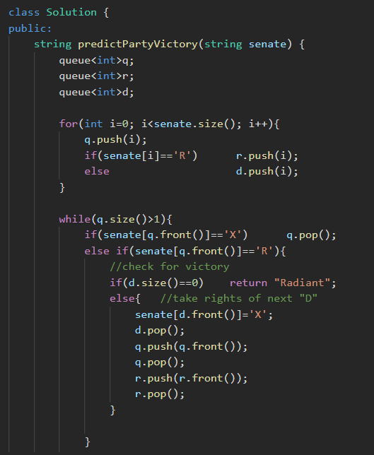

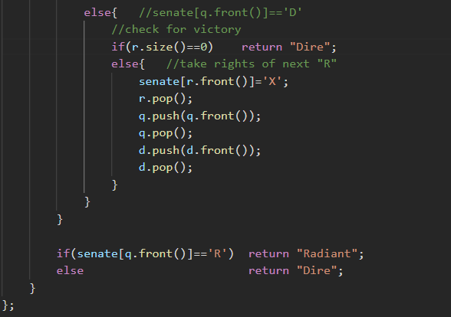

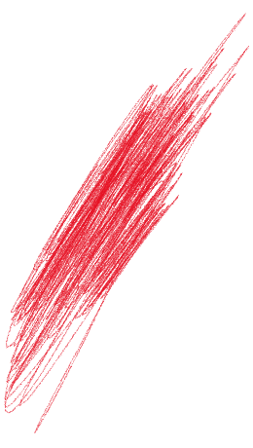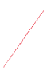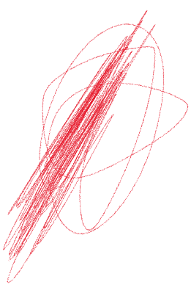 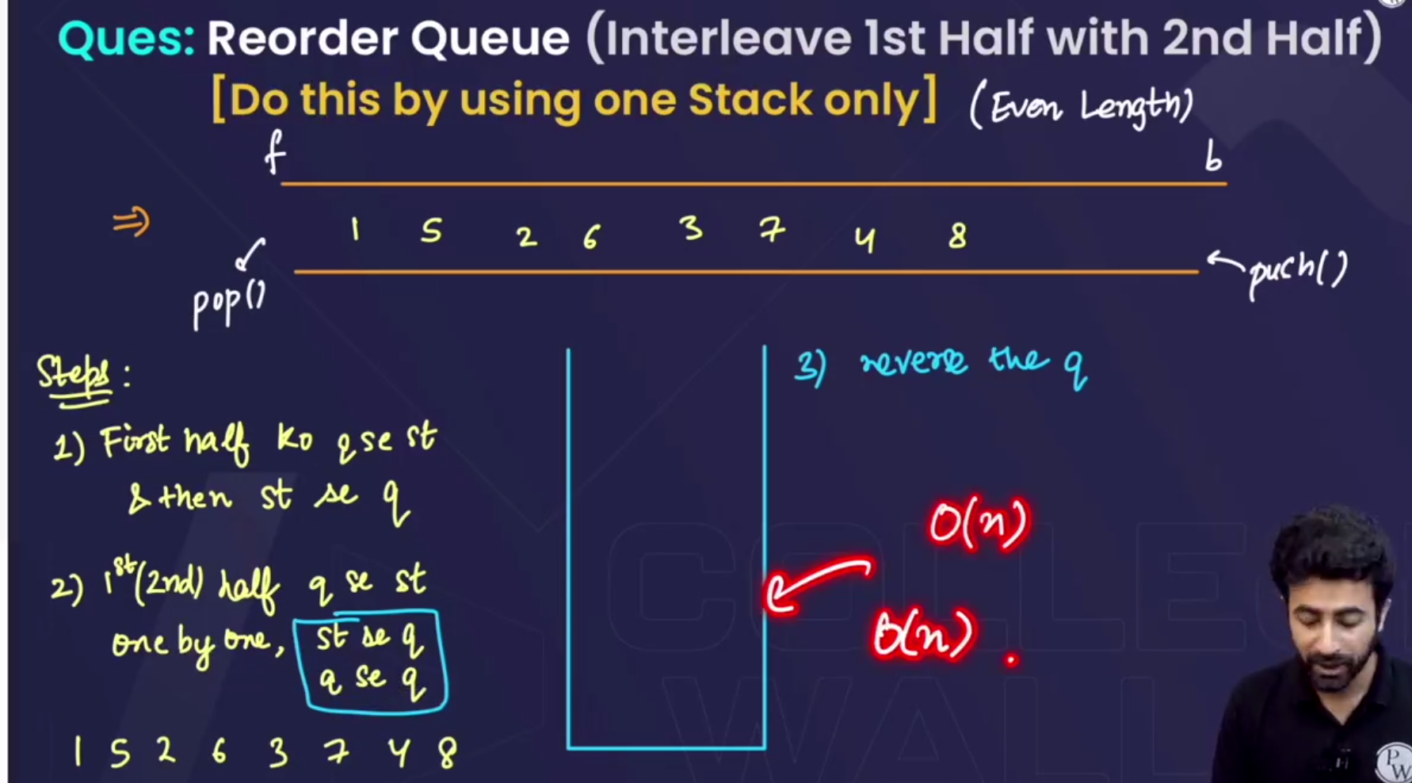

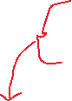

* a queue of even length will be given



* + Eg: 1 2 3 4 5 6 7 8 🡪and we have to convert it like🡪1 5 2 6 3 7 4 8

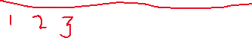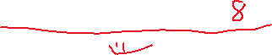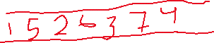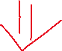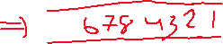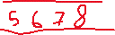

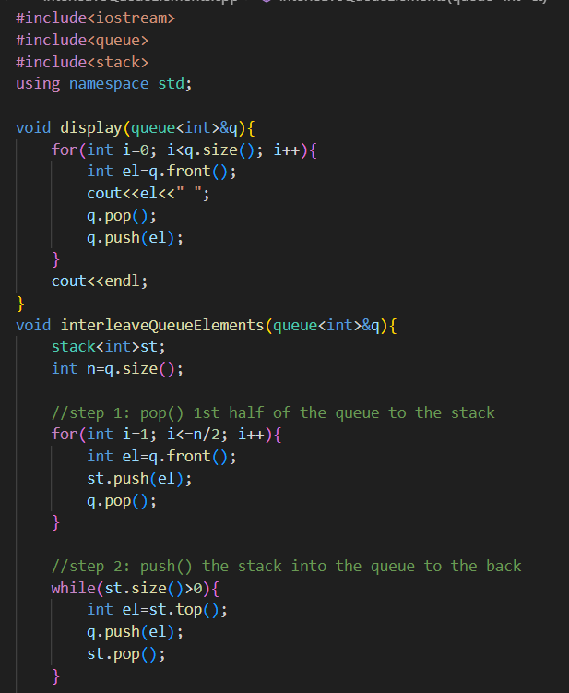

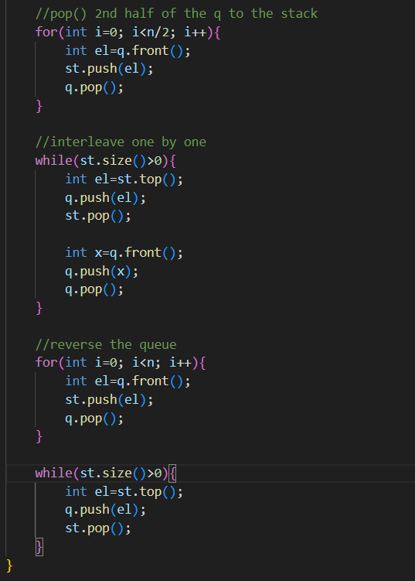

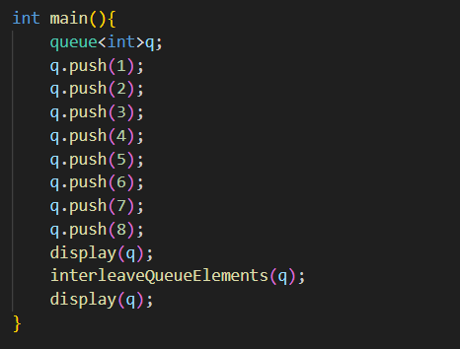

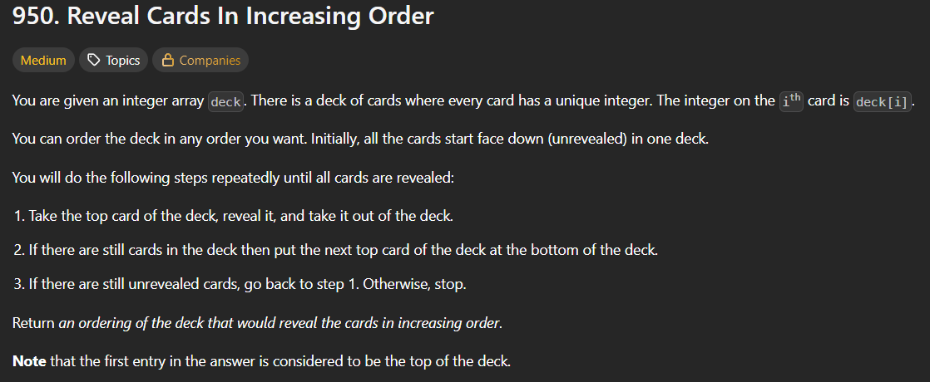 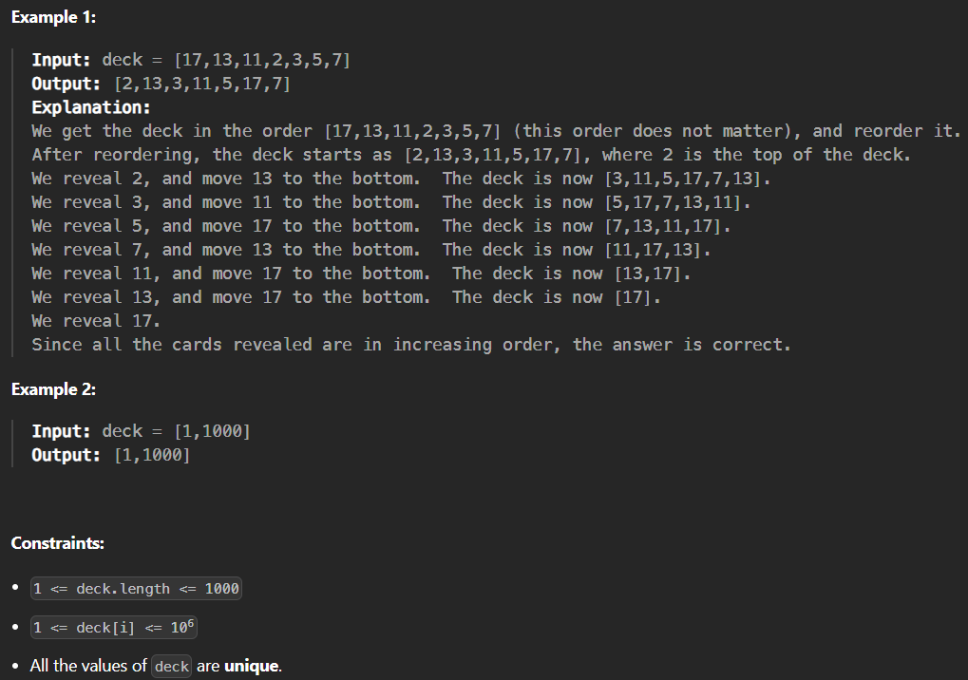 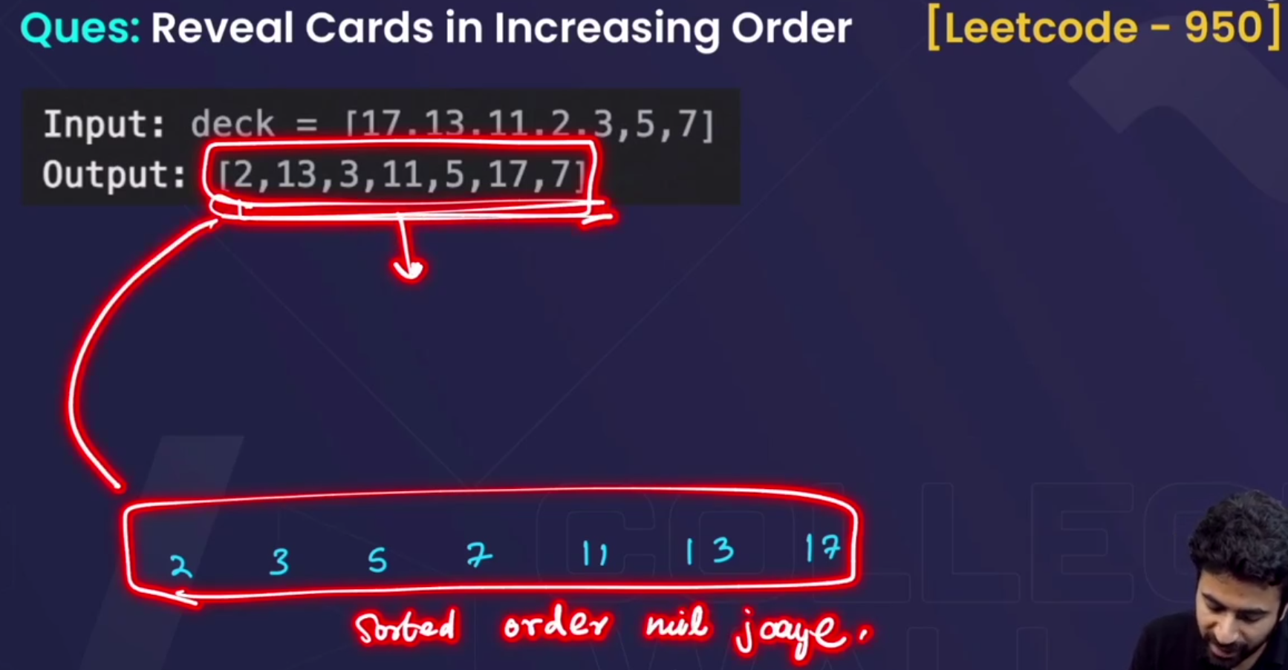

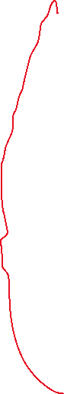

* Input deck will be given , and we have to we have to return an array jisko agar hm ek reveal kre and ek peeche behjte jaaye to hme ek sorted array mil jaaye.

